**Databricks Mlflow**

**Introduction**

**What is Databricks?**

Databricks combines the best of data warehouses and data lakes into a lakehouse architecture.

Collaborate on all of your data, analytics and AI workloads.

It’s a one-stop product for all data needs, from data storage, analysis data and derives insights using SparkSQL, build predictive models using SparkML.

It also provides active connections to visualization tools such as PowerBI, Tableau, etc.

**What is Mlflow?**

MLflow is an open source platform for managing the end-to-end machine learning lifecycle. It has the following primary components:

**Tracking:** Allows you to track experiments to record and compare parameters and results.

**Models:** Allow you to manage and deploy models from a variety of ML libraries to a variety of model serving and inference platforms.

**Projects:** Allow you to package ML code in a reusable, reproducible form to share with other data scientists or transfer to production.

**Model Registry:** Allows you to centralize a model store for managing models’ full lifecycle Stage transitions: from staging to production, with capabilities for versioning and annotating.

**Model Serving:** Allows you to host MLflow Models as REST endpoints.

MLflow supports Java, Python, R, and REST APIs.

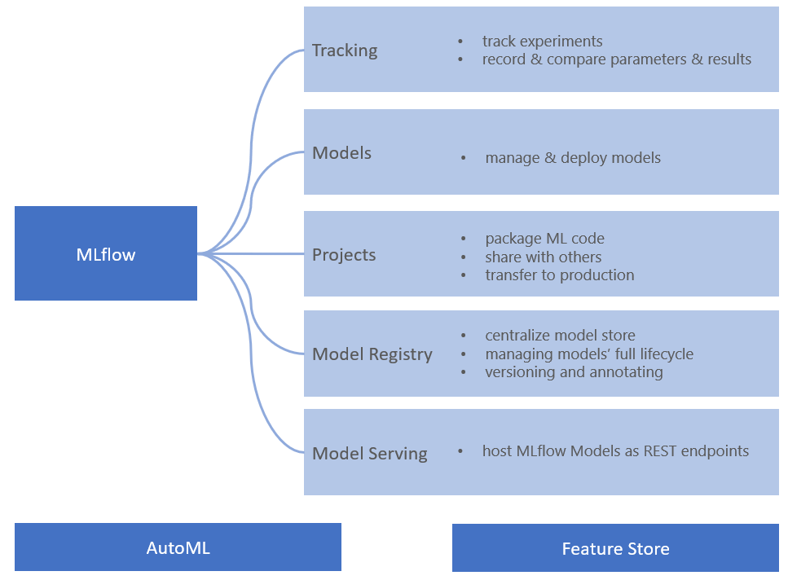

**MLflow: Dynamic Experiment counter and Reproduce run button**

**1)MLflow Experiment Dynamic Counter**

The MLflow UI is tightly integrated within a Databricks notebook. As you train your model using MLflow APIs, the Experiment label counter dynamically increments as runs are logged and finished, giving data scientists a visual indication of experiments in progress.

By clicking on the Experiment, a side panel displays a tabular summary of each run’s key parameters and metrics, with ability to view detailed MLflow entities: runs, parameters, metrics, artifacts, models, etc.

**2) MLflow Reproducible Run button**

Another feature improvement is the ability to recreate a notebook run to reproduce your experiment. From any of the MLflow run pages, a Reproduce Run button allows you to recreate a notebook and attach it to the current or shared cluster.

**Step by step guide to Databricks**

Databricks community edition is free to use, and it has 2 main Roles:

1. Data Science and Engineering

2. Machine learning.

**How to best use the Databricks environment for experimentation:**

Upload data

1) A new feature Upload Data, with a notebook File menu, uploads local data into your workspace.

2)however, you can select the destination and use the code from the Upload File dialog to read your files. In our case, we select the pandas code to read the CSV files.

NOTE:Directly we can upload from local system.

**Dashboarding on Databricks**

Databricks has a feature to create an interactive dashboard using the already existing codes, images and output.

Move to View menu and select + New Dashboard

Provide a name to the dashboard.

On the Top Right corner of each cell click on the tiny Bar Graph image.

It will show the available dashboard for the notebook.

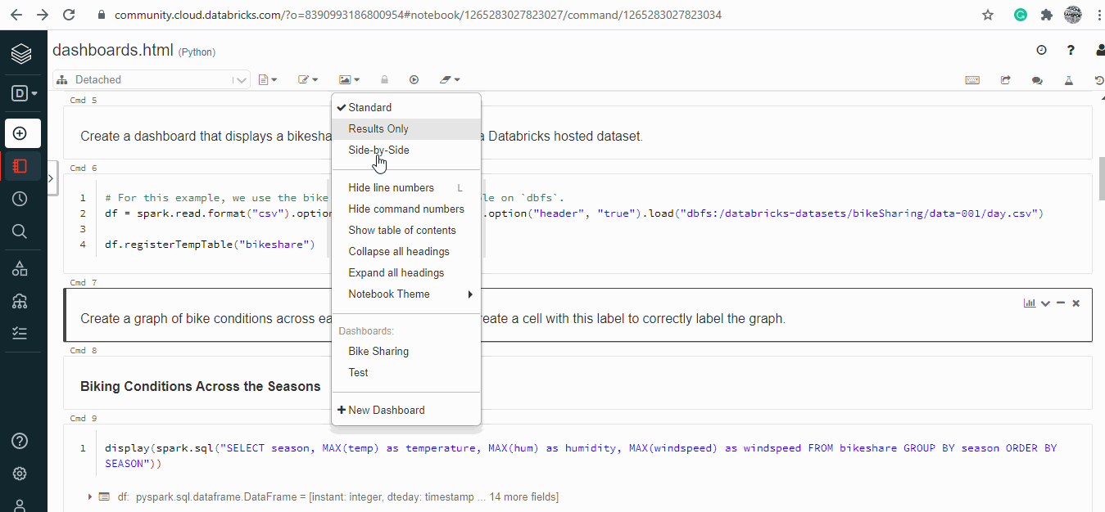

**Cluster**

An Azure Databricks cluster is a set of computation resources and configurations on which you run data engineering, data science, and data analytics workloads, such as production ETL pipelines, streaming analytics, ad-hoc analytics, and machine learning.You can manually terminate and restart an all-purpose cluster.

**Steps to create cluster:**

Create-->Cluster-->Enter cluster name-->Click on CREATE CLUSTER button

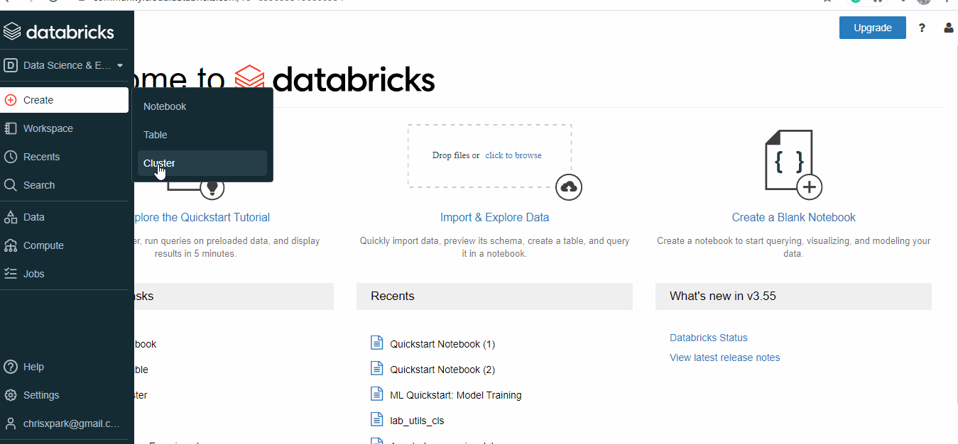

**To see existing clusters:**

Go to COMPUTE-->we can see all clusters that were created

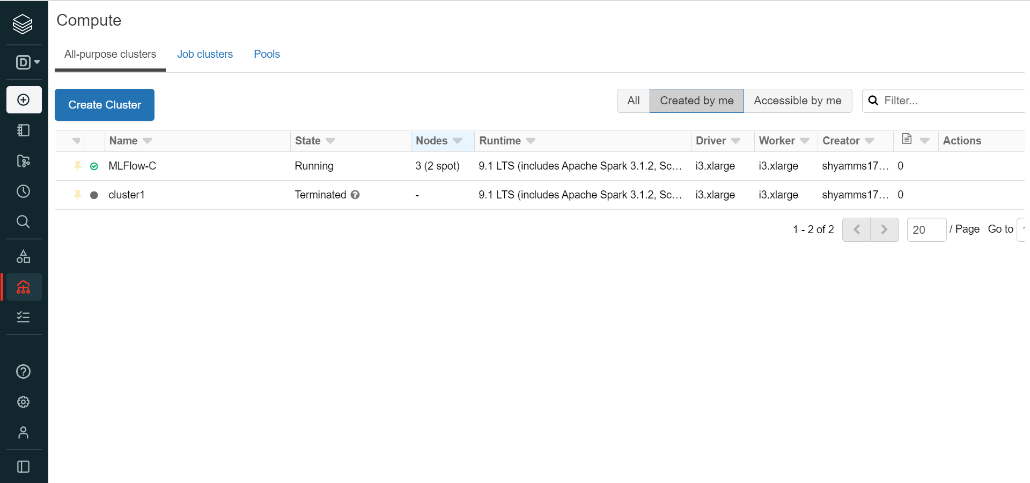

**Web terminal to log into the cluster**

Any member of a data team, including data scientists, can directly log into the driver node from the notebook. No need to use %sh ssh magic commands, which require tedious setup of ssh and authentication tokens.

**Notebook**

Notebooks in Databricks are similar to Jupyter notebooks, but they have enhanced them quite a bit. ... Give your notebook a name, what language you want to use (Databricks supports Python, R, Scala, and SQL), and what cluster to associate it to.

**Steps to create a notebook:**

Create-->Notebook-->Enter notebook name->Click on CREATE button

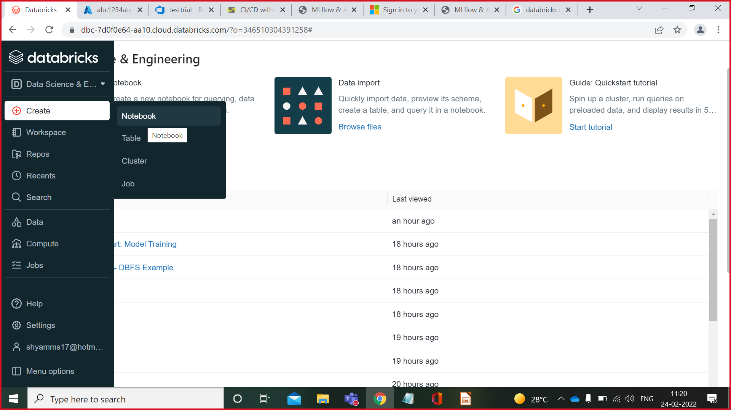

**Steps to open existing Notebook:**

Go to workspace-->Select user-->Click on notebook that you want to open

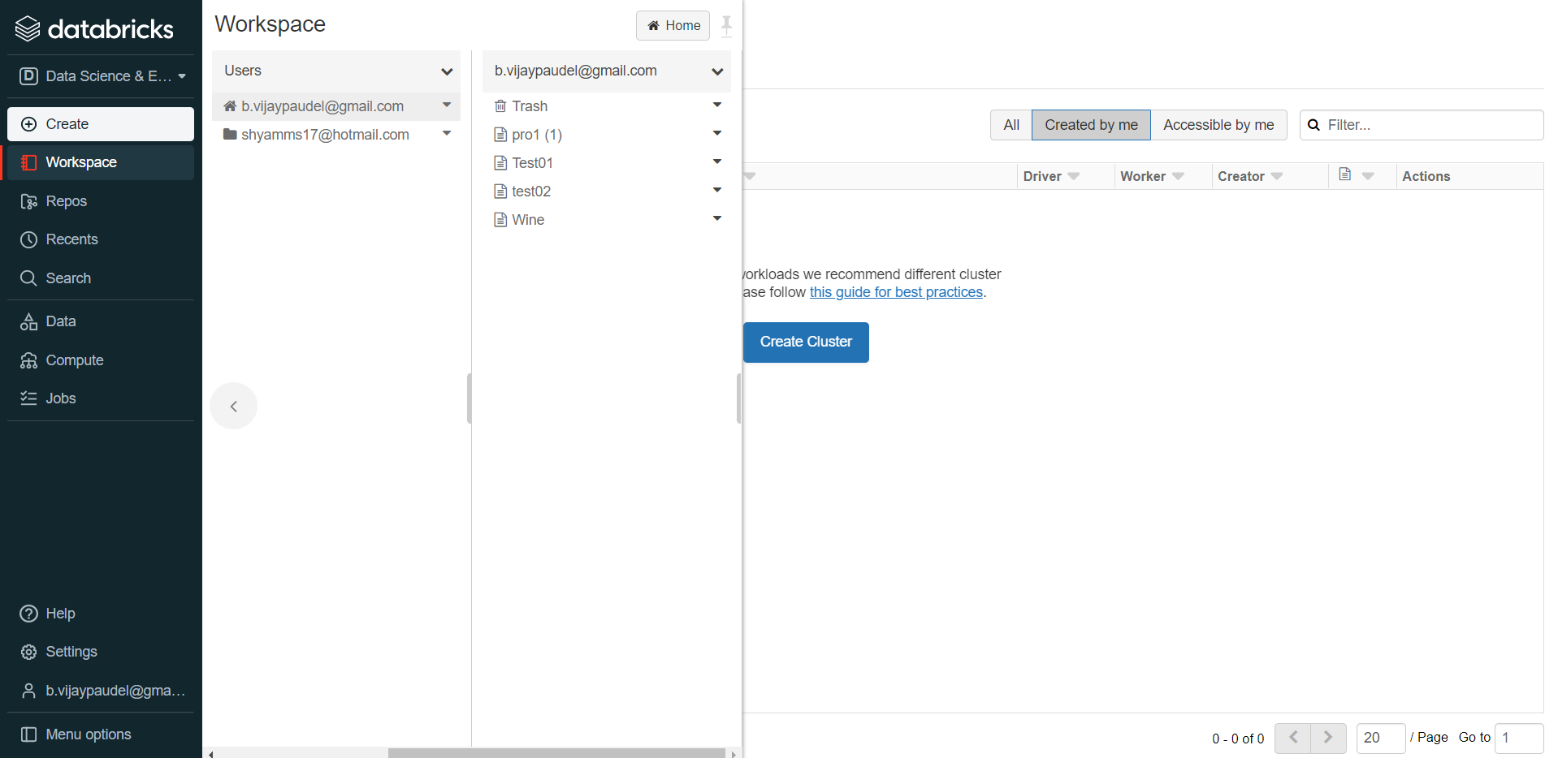

**Attach existing cluster to new/existing Notebook**

In the top left corner of notebook click on dropdown-->Select appropriate CLUSTER and click on ATTACH(cluster gets attached to the notebook)

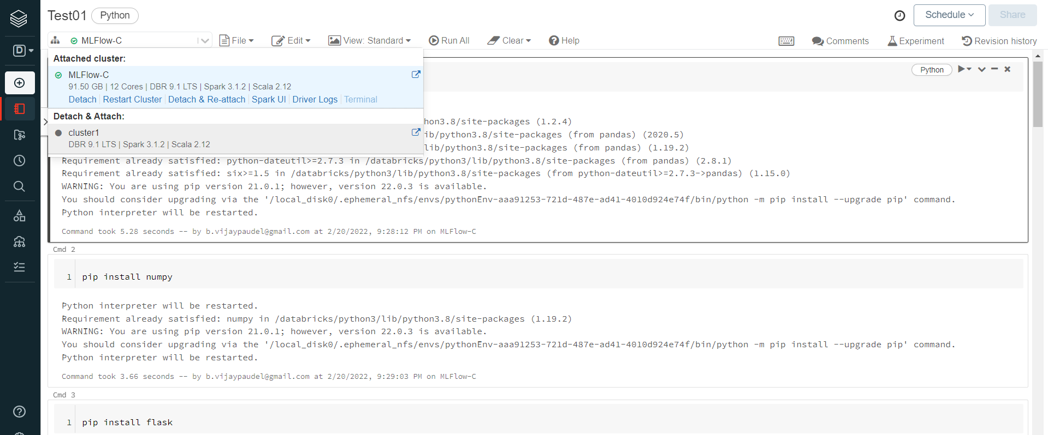

**Storing Data files**

**Steps to create table from csv file:**

Create-->Table-->Upload files-->Drop files to upload, or Click to browse and Select the file-->**(**Create table with UI-->Select the cluster-->Preview table-->Click on create table button**/**Create table with notebook-->Run the code to create table**)**

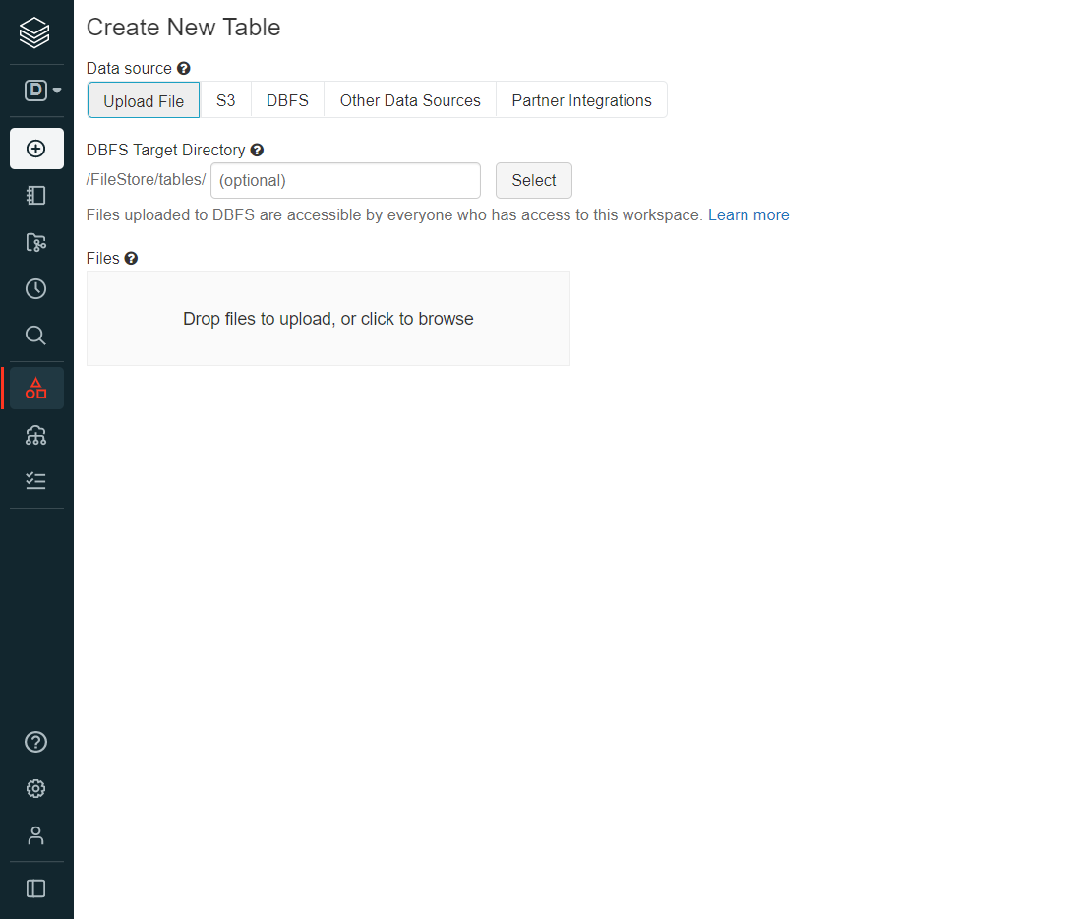

**To see existing Tables:**

Go to data-->Database-->Tables

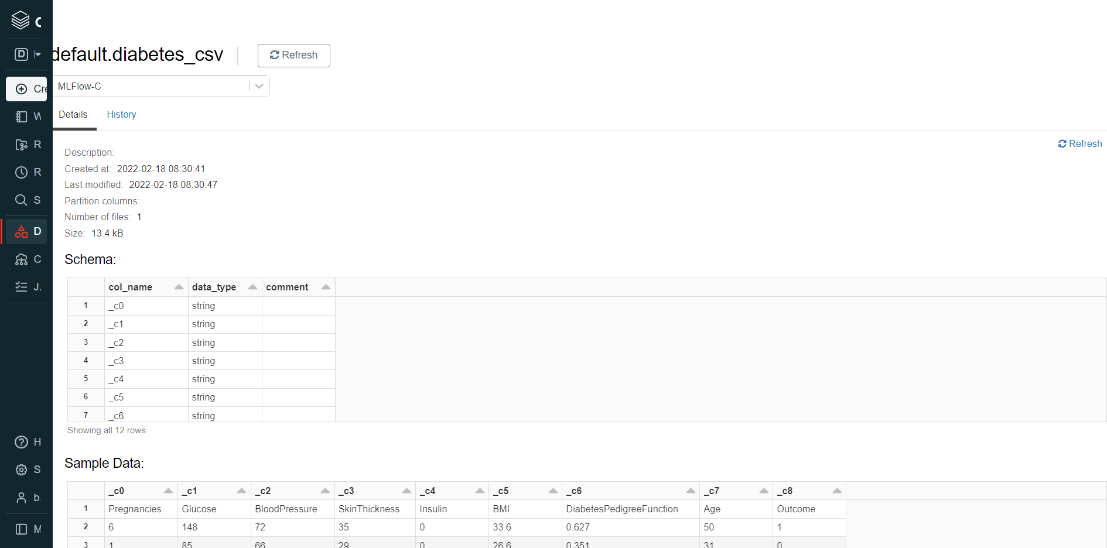

**Add users in Databricks account**

Settings-->Admin console-->Add user-->In popup add users email id(User will get invitation mail to set password)

Once done user can directily login to databricks account and have all access

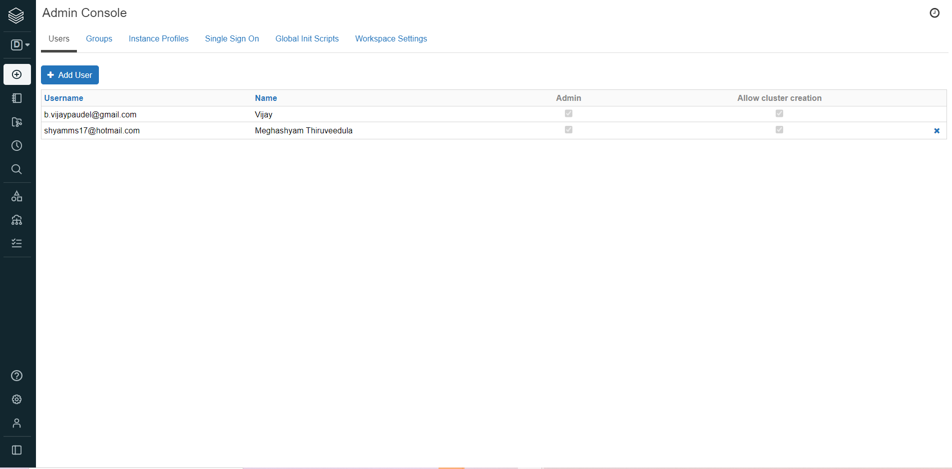

**Steps to see all added Users:**

settings-->admin console(U can see all added users)

**Register a model that gives best prediction in Experiment**

In notebook run the prediction code-->Select EXPERIMENT below the prediction code-->Click on appropriate model(sklearn)-->Register model-->Click on dropdown-->Create new model-->Give model name-->Register-->Model is saved with given name.

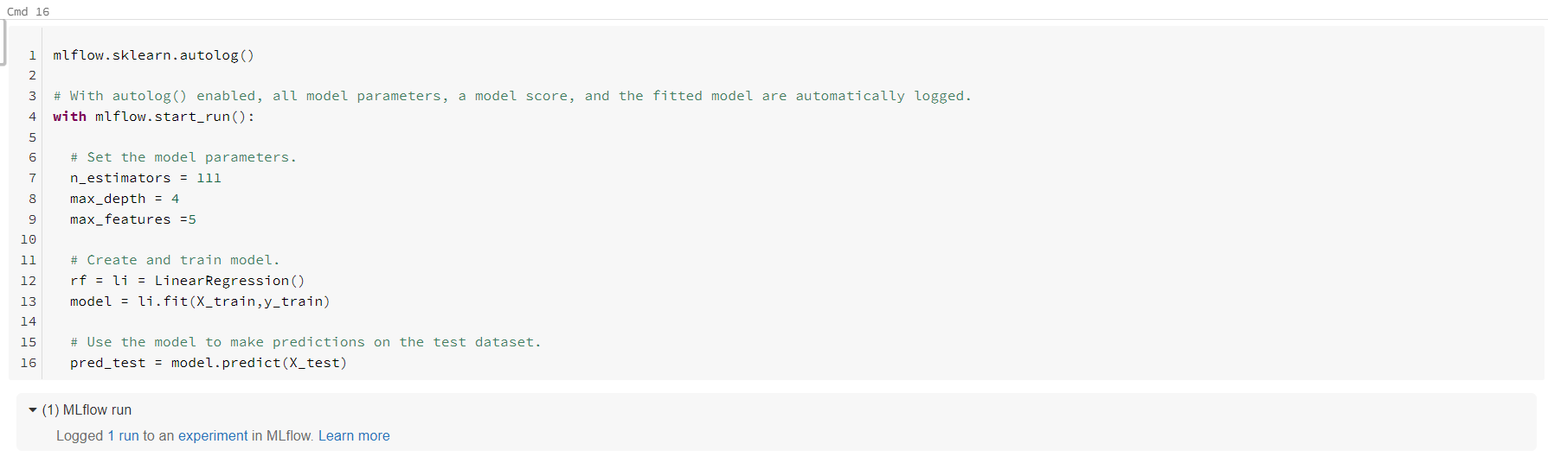

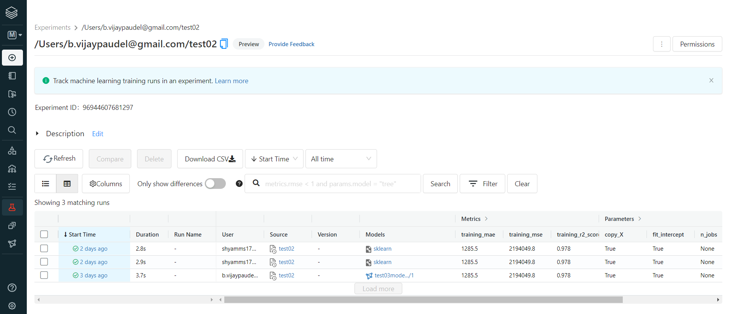

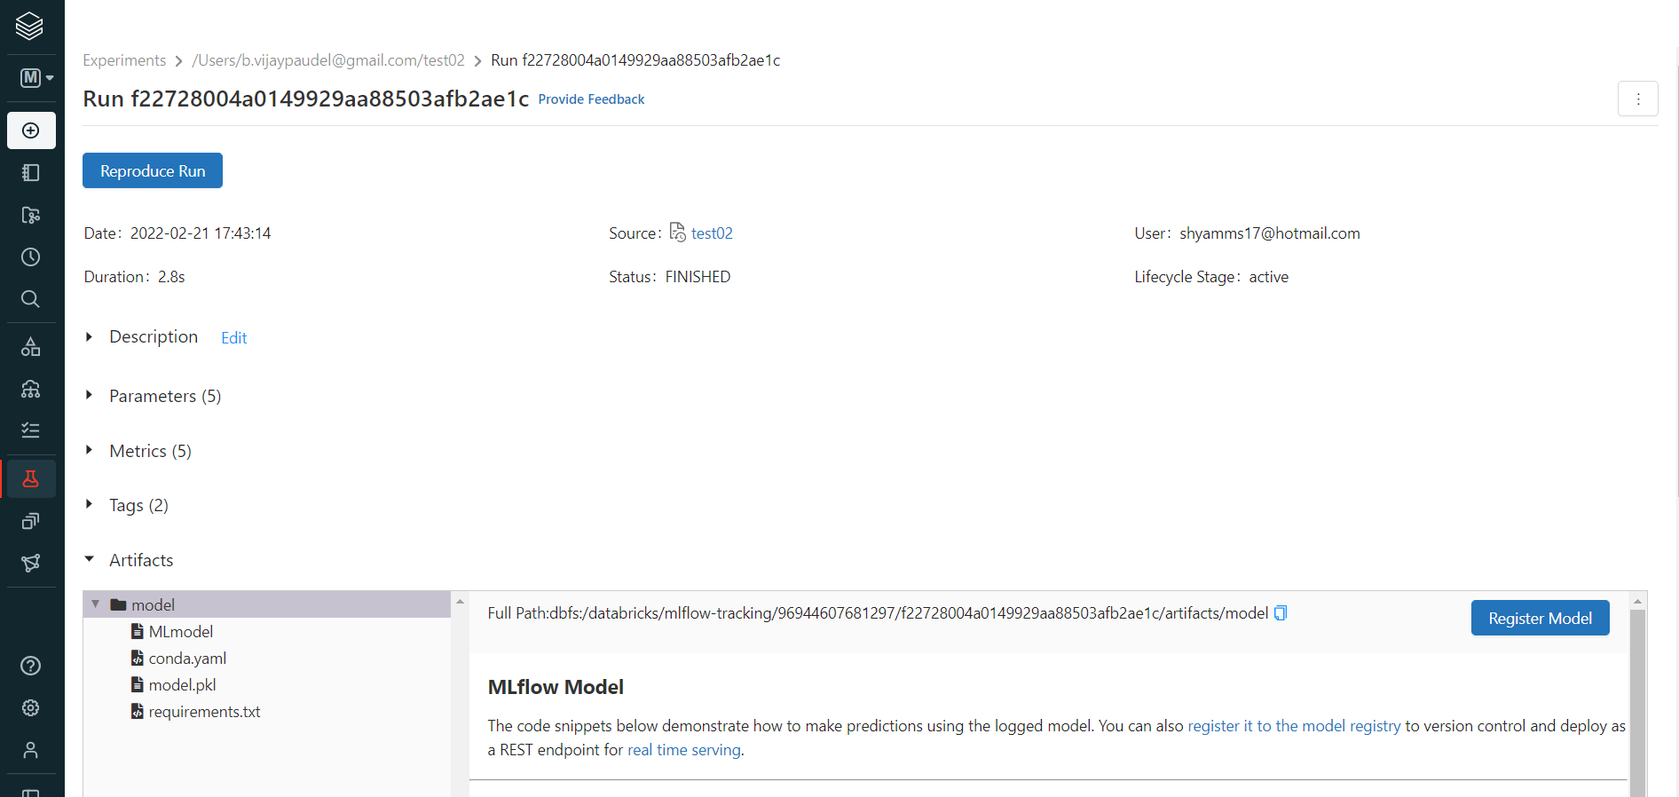

**To download all files of registered model:**

In notebook run the prediction code-->Select experiment below the prediction code-->Click on registered model--> Click on SOURCE RUN link-->Under Artifacts**(**Under model-->download required files**)**

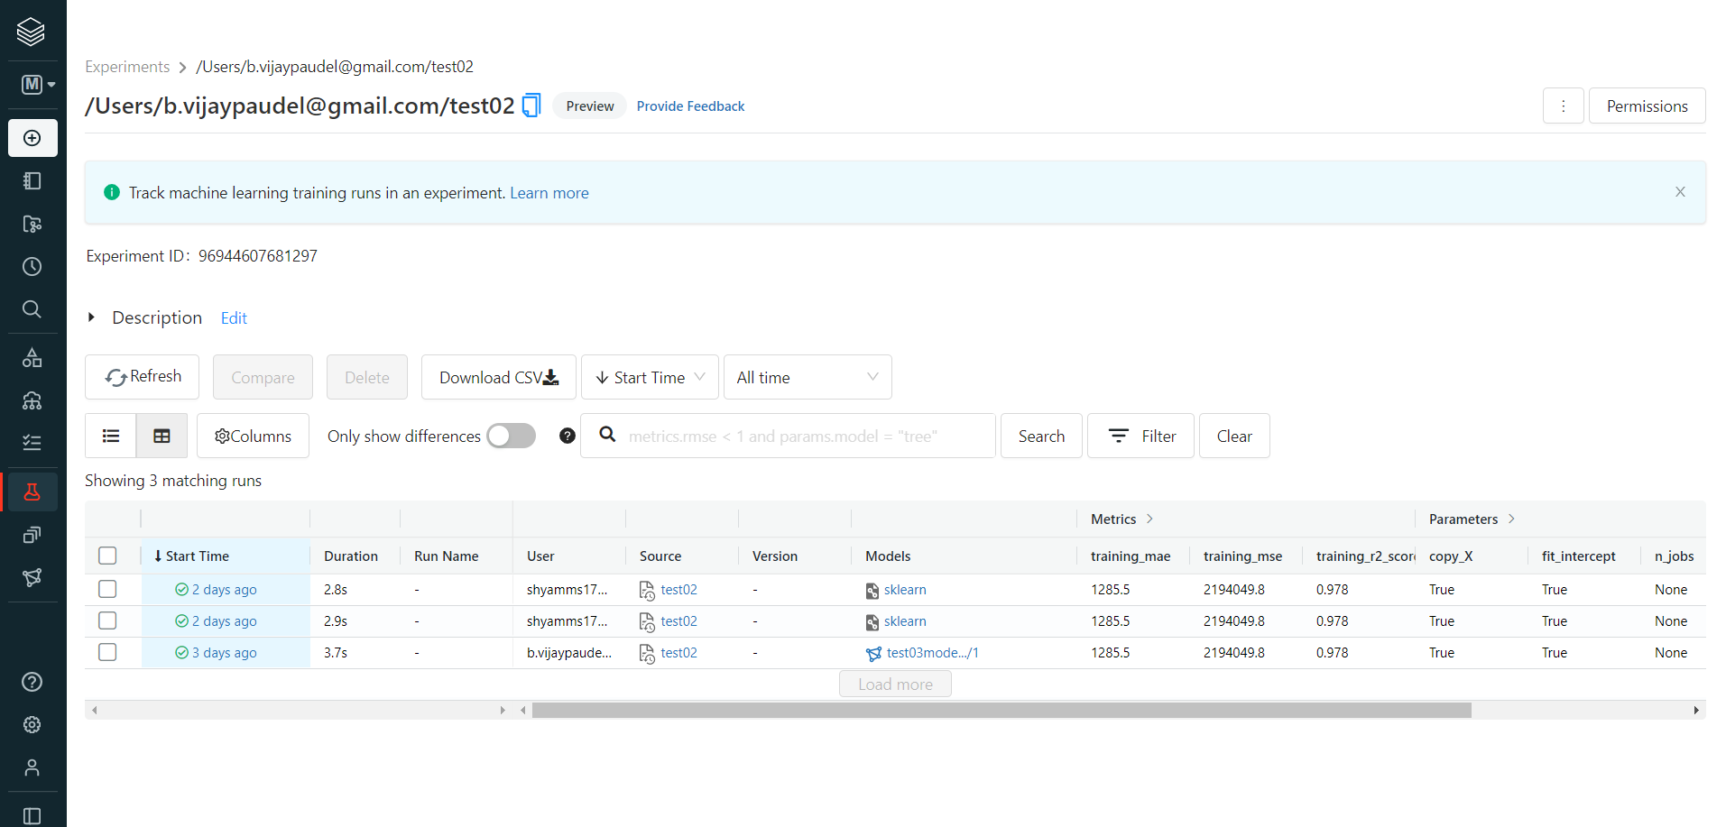

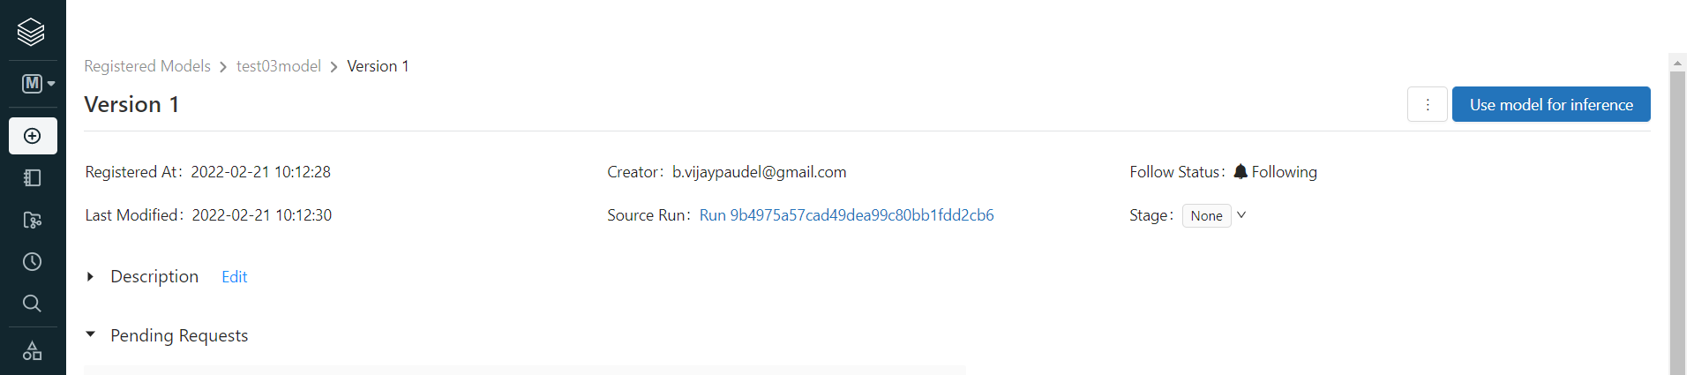

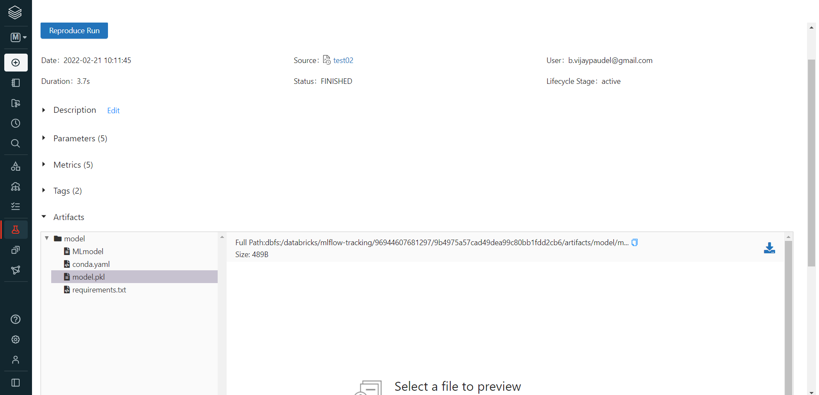

**Jobs in Databricks**

Jobs helps us to execute our Notebooks on Scheduled basis and alerts are sent to user through Email.

Go to Databricks-→Jobs-→Create new jobs-→Provide Task Name-→Select Notebook-→Click on Create button.

**To Schedule Job**

Go to jobs-→Click on Job Name-→Edit Schedule-→Give appropriate time -→save

**For Alert Notification**

Go to jobs-→Click on Job Name-→click on Edit Alert Button-→Click on Add-→Add Email address-→click in Confirm Button

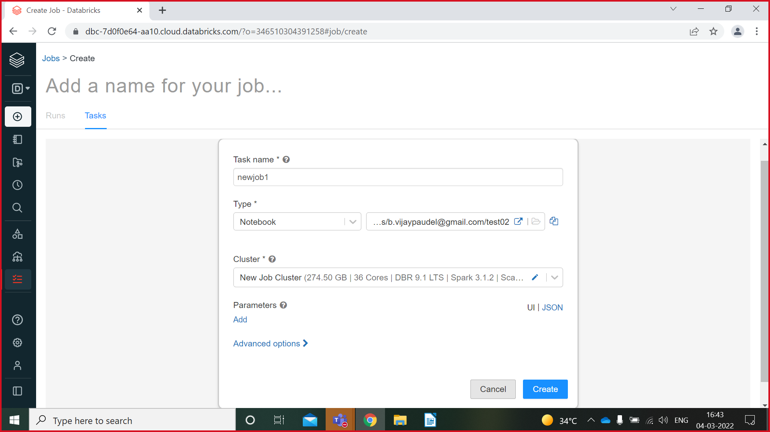

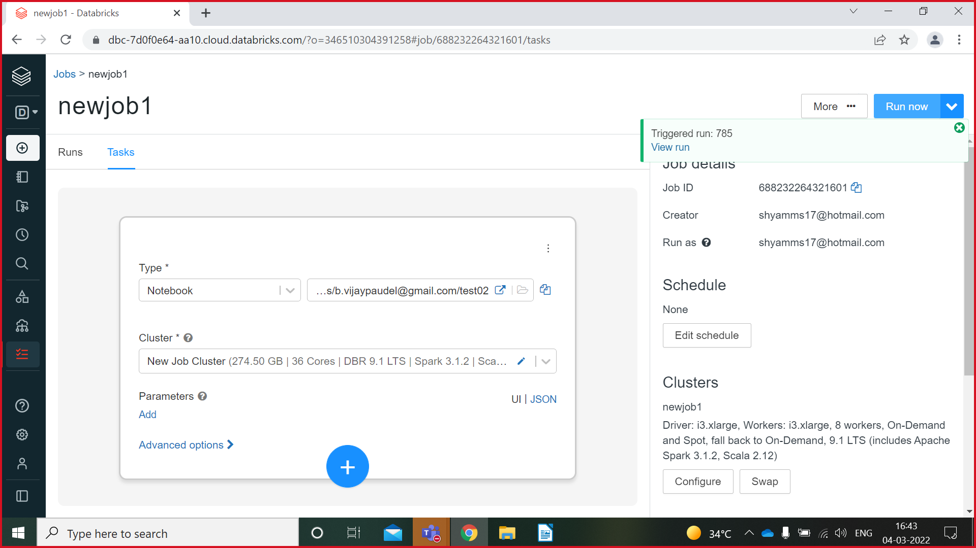

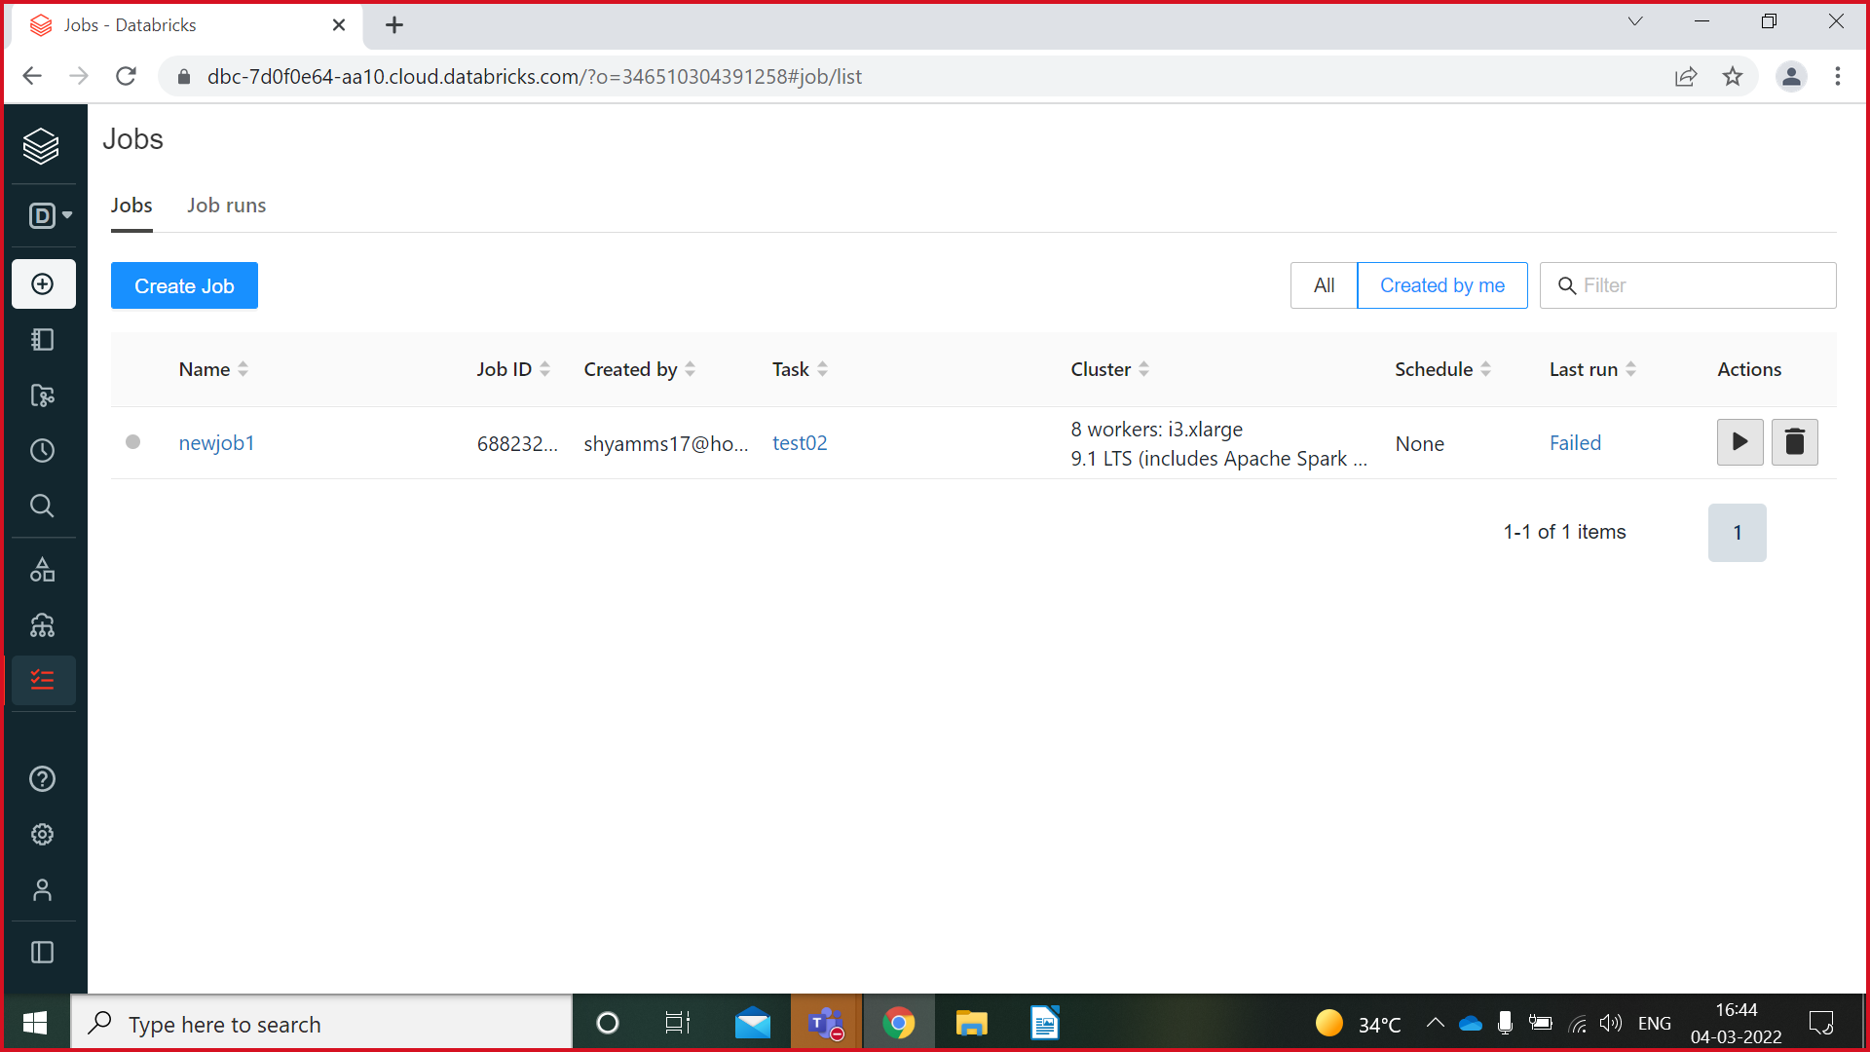

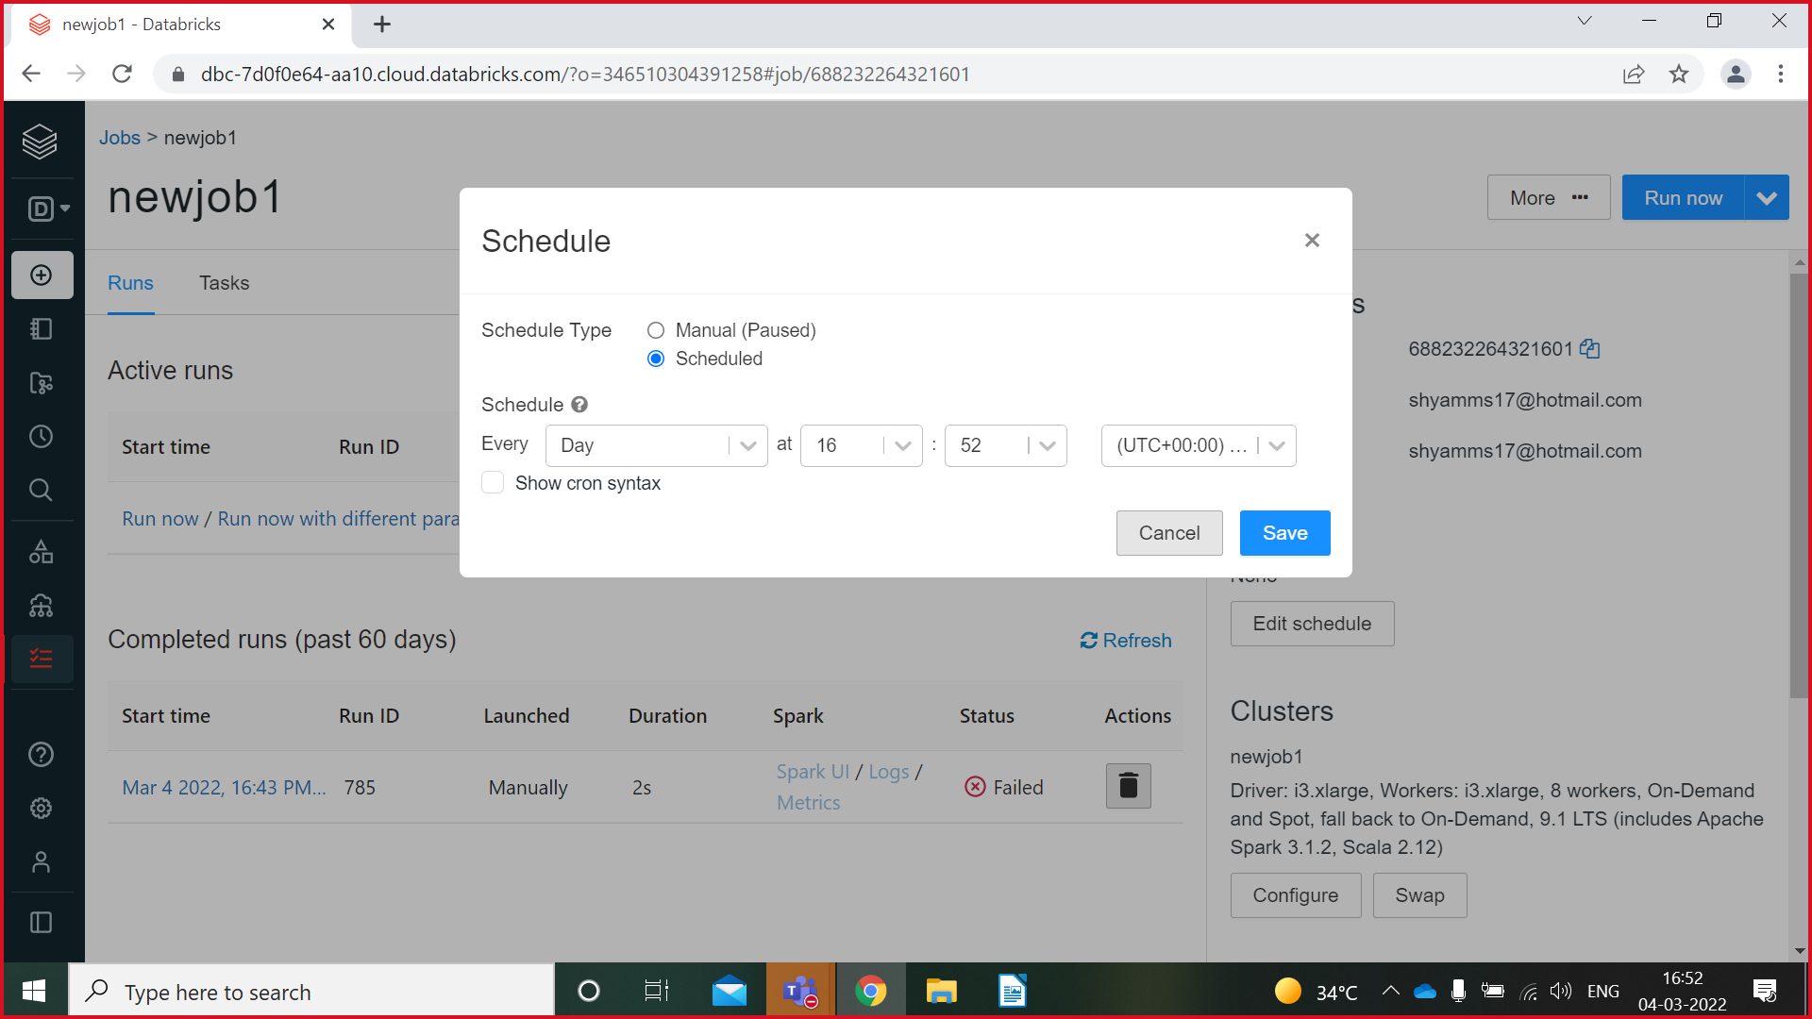

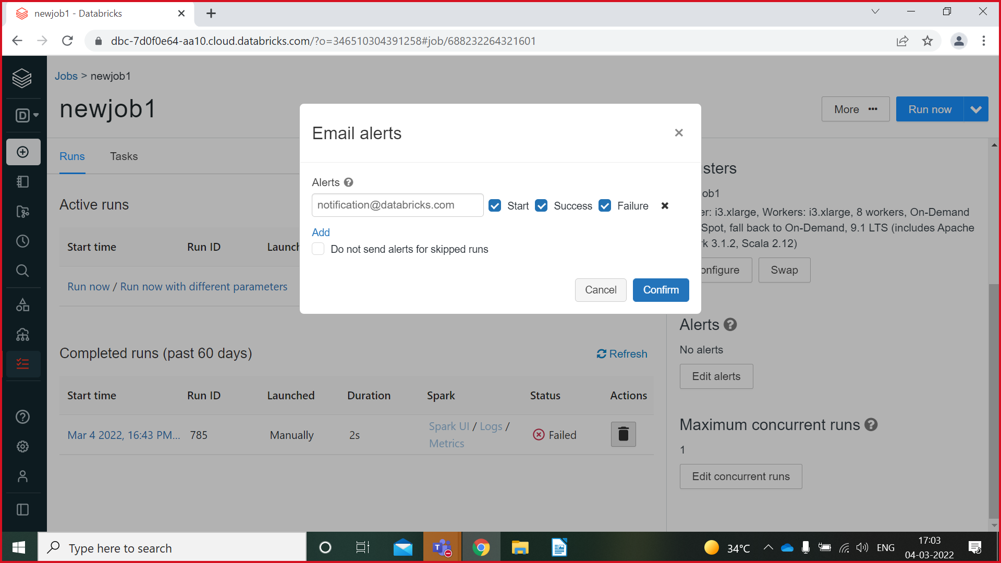

**Feature Store In Databricks**

You can use Databricks Feature Store to create new features, explore and re-use existing features, select features for training and scoring machine learning models, and publish features to low-latency online stores for real-time inference.

Databricks Feature Store is fully integrated with other Databricks components. Feature tables are stored as Delta tables. Deployed MLflow models can automatically retrieve features from Feature Store. The Databricks Feature Store UI, accessible from the Databricks workspace, lets you browse and search for existing features and displays information about feature lineage—including data sources used to compute features and the models, notebooks, and jobs that use a specific feature.

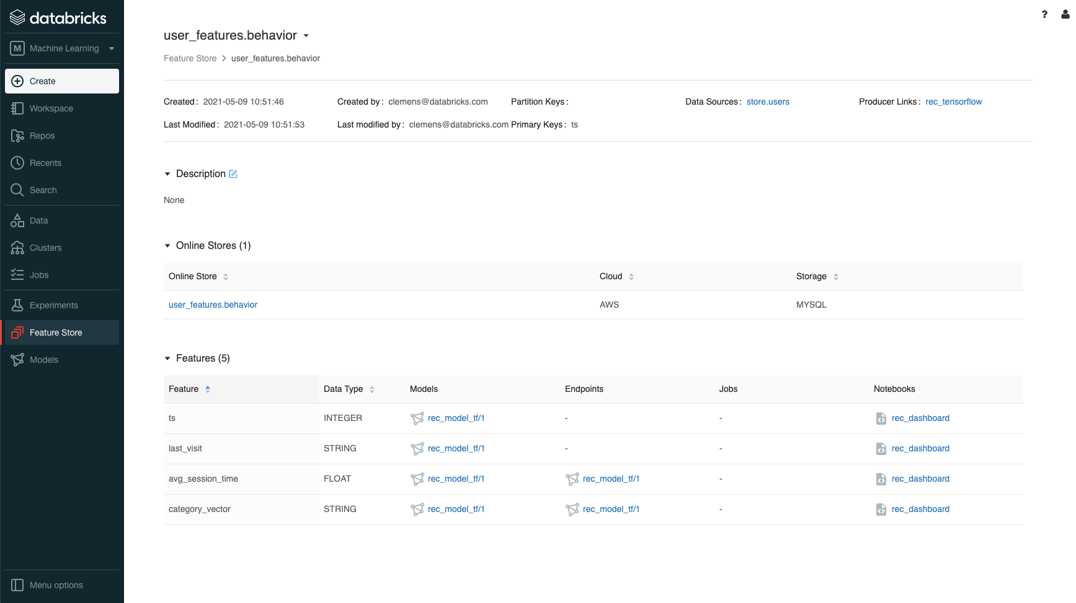

**Link databricks to Azure Devops**

Databricks-->Settings-->User settings-->Git integration-->Change settings-->**((**Git provider-->Azure devops service**)(**Git provider username or email-->Username of azure devops account**)(**To get Token-->Go to azure devops account-->Click on user settings on top right-->Personal access token-->Click on new token-->Give name of token-->Under scope give full access-->Create-->Copy token from popup window and save it in notes as we cannot get that token again**))**-->Paste that token in databricks token--> Click on Save Button.

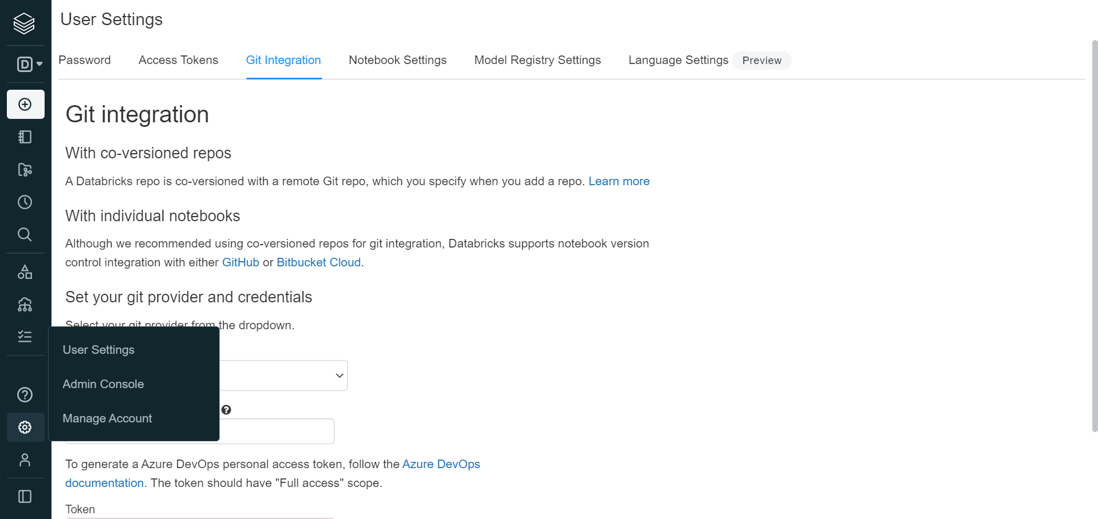

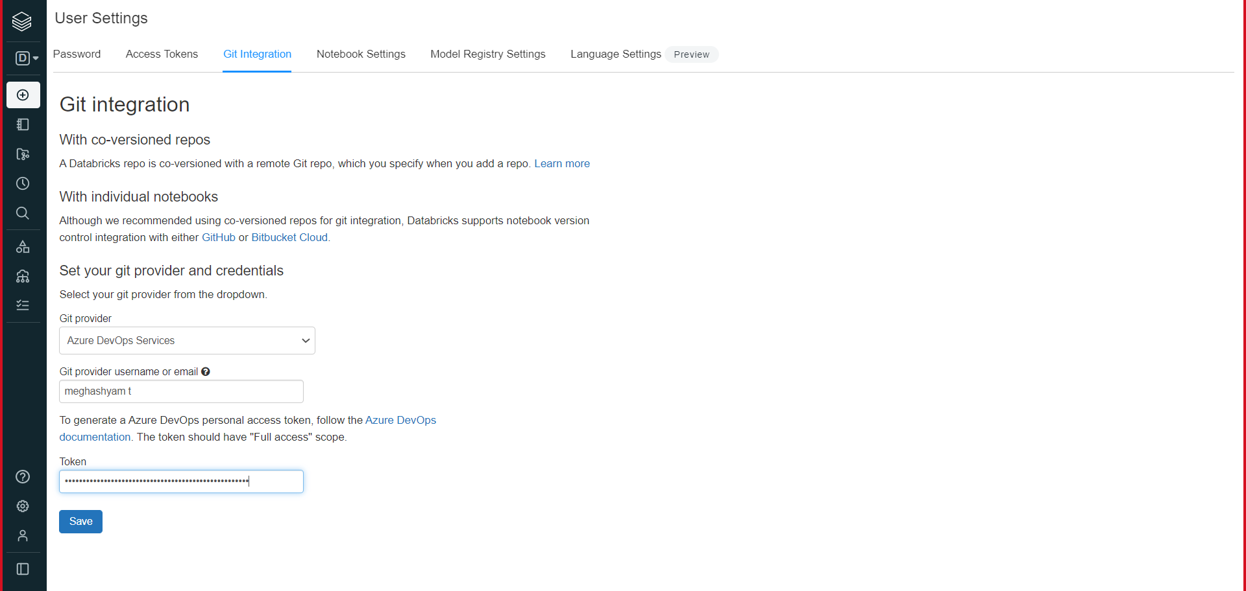

**To get Token from Azure Devops**



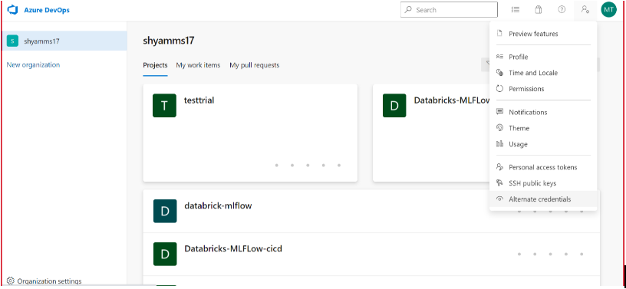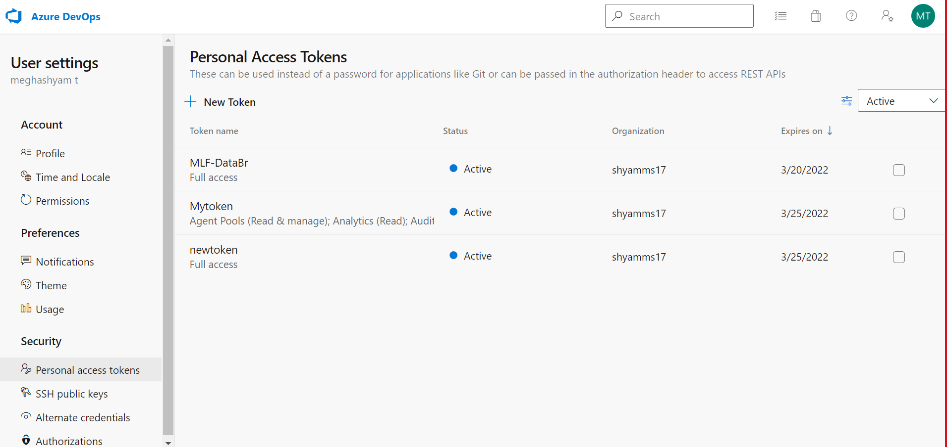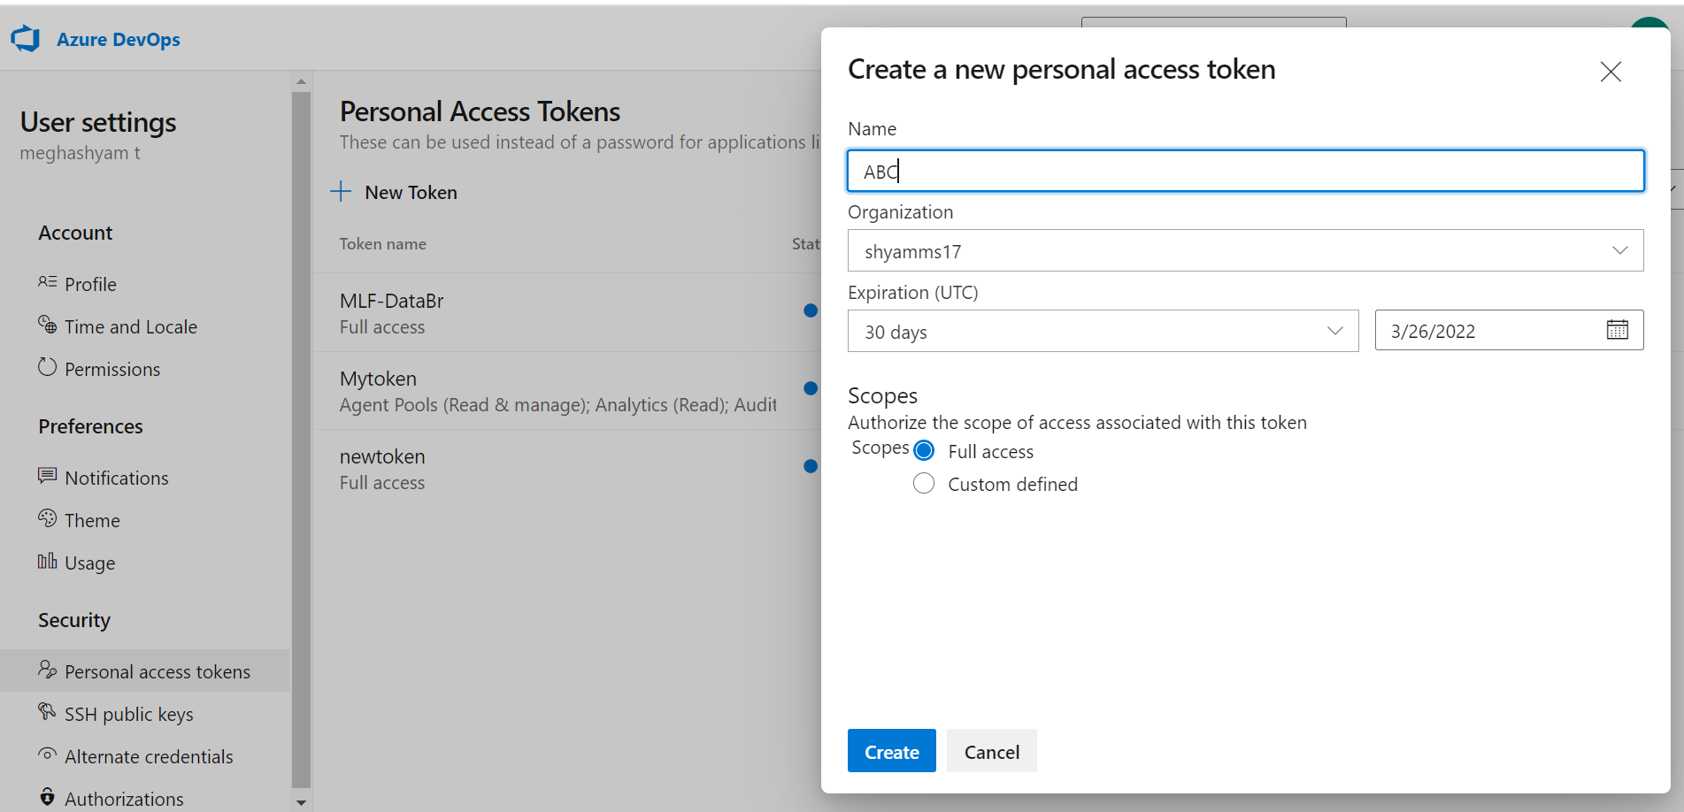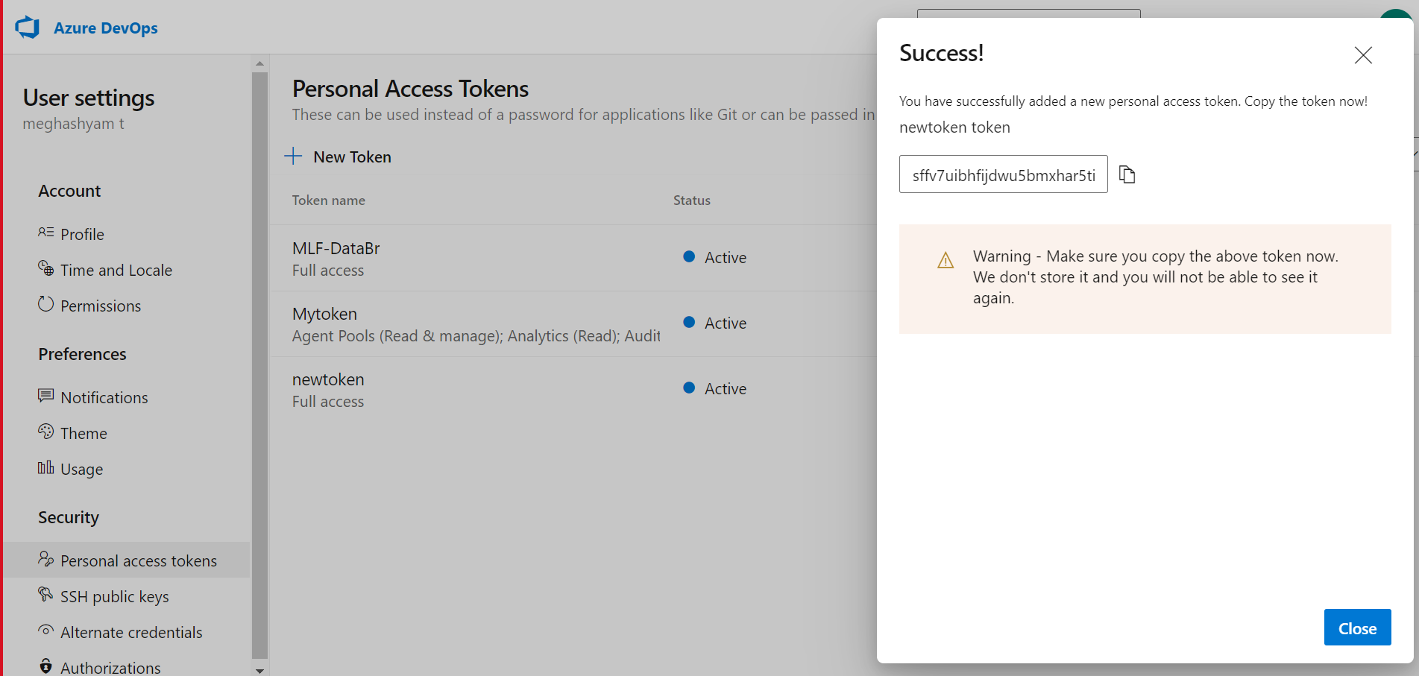

**Note: You can regenerated the token that is already created in Azure Devops**

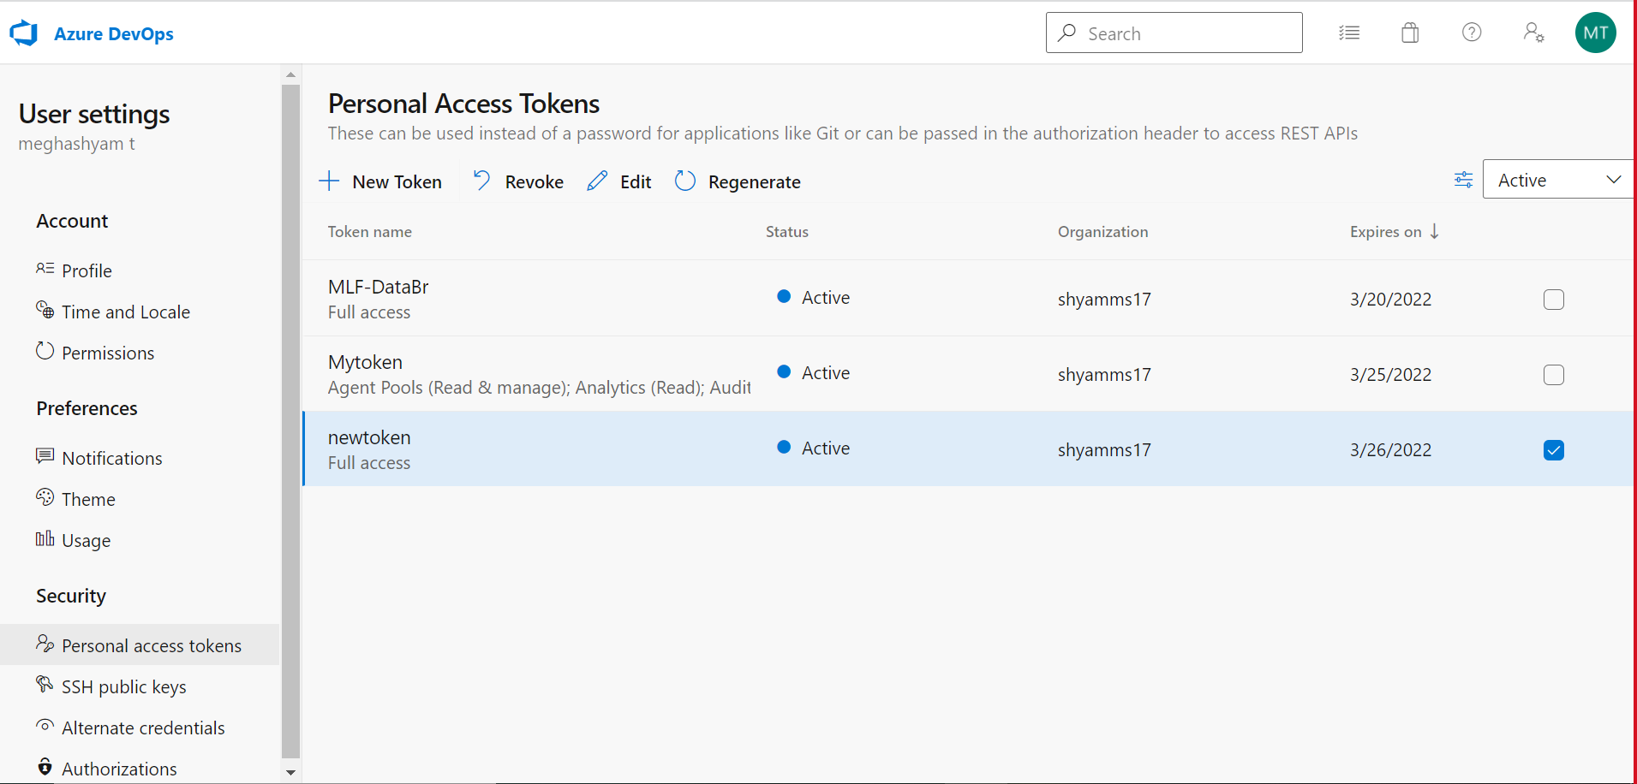

**Link databricks to GIT**

Databricks-->Settings-->User settings-->Git integration-->Change settings-->**((**Git provider-->GITHUB**)(**Git provider username or email-->Username of Github account**)(**To get Token-->Go to Github account-->Click on user icon on top right-->Settings-->**<>**Developers settings-->Personal Access Token-->Generate New Token-->Give name of token in Note-->Give all access under scopes-->Generate Token-->Copy token and save it in notes as we cannot get that token again**))**-->Paste that token in databricks token--> Click on Save Button.



**To get Token from GIT**

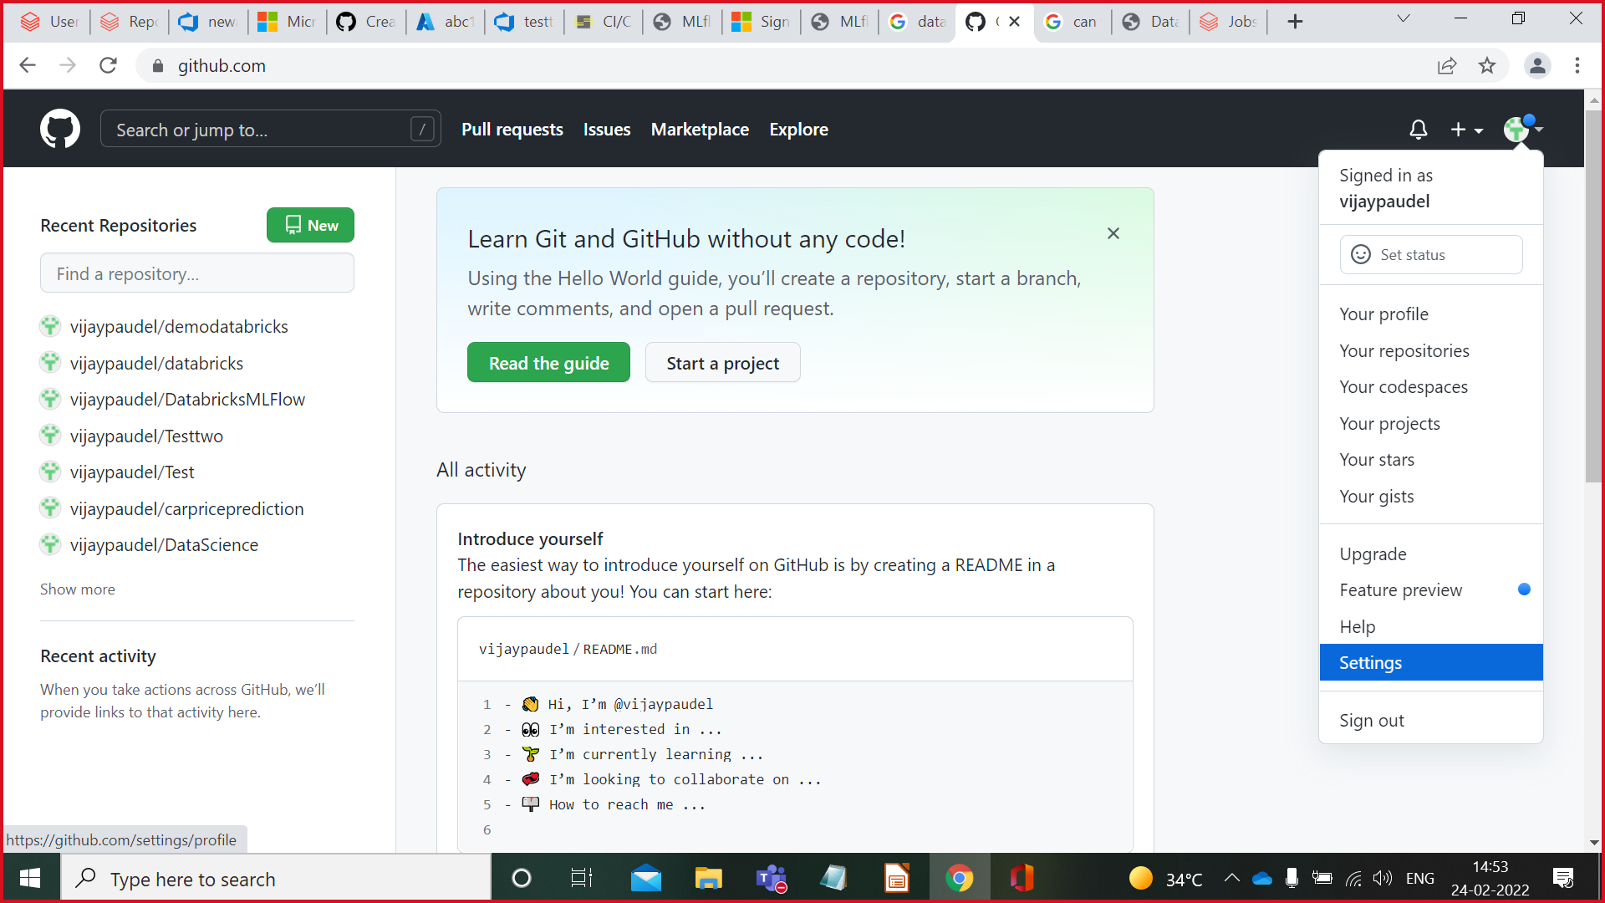

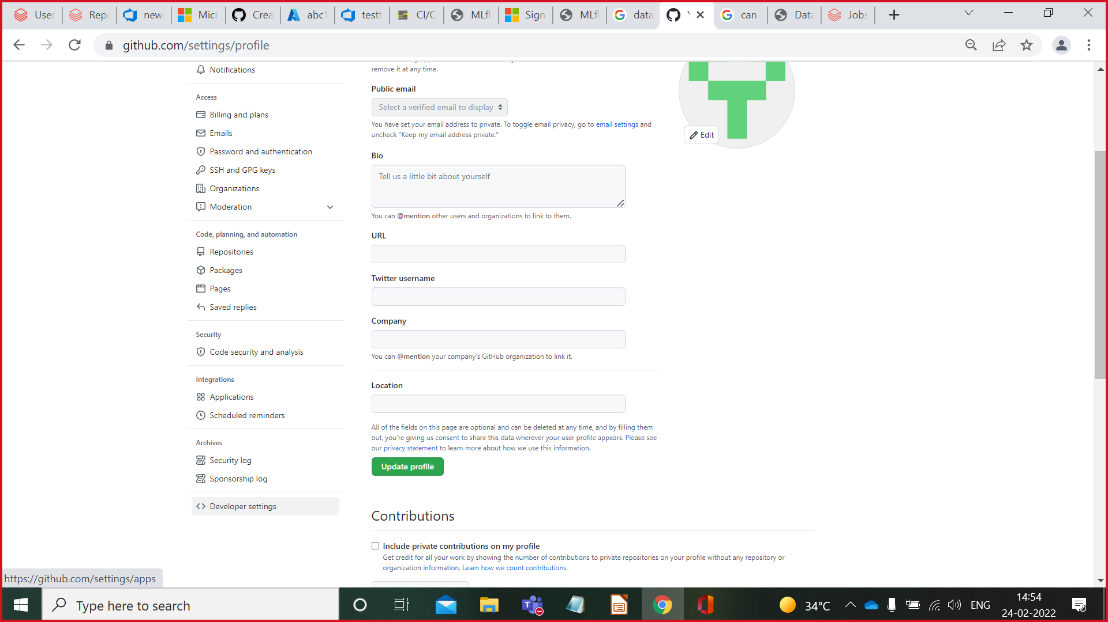

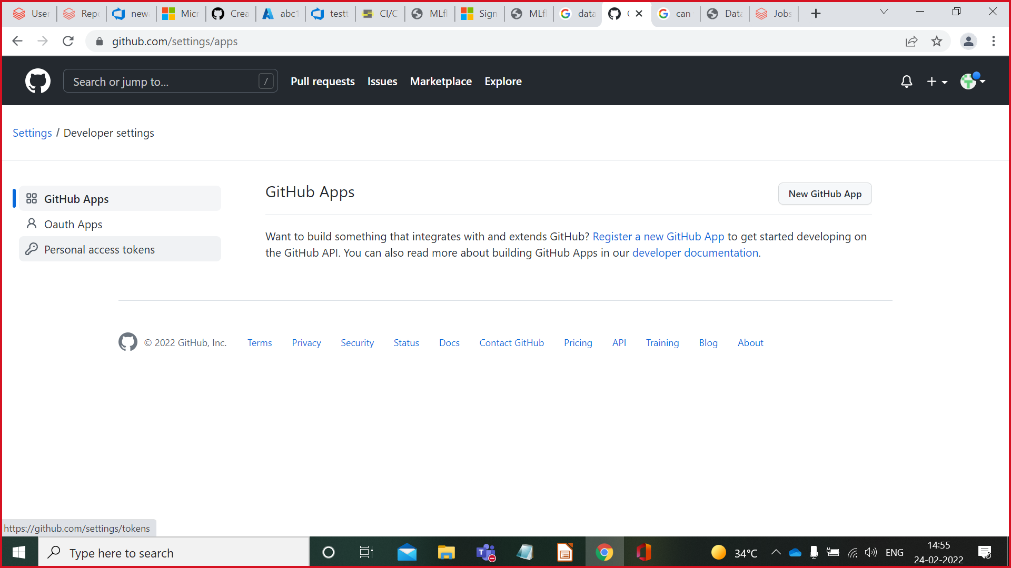

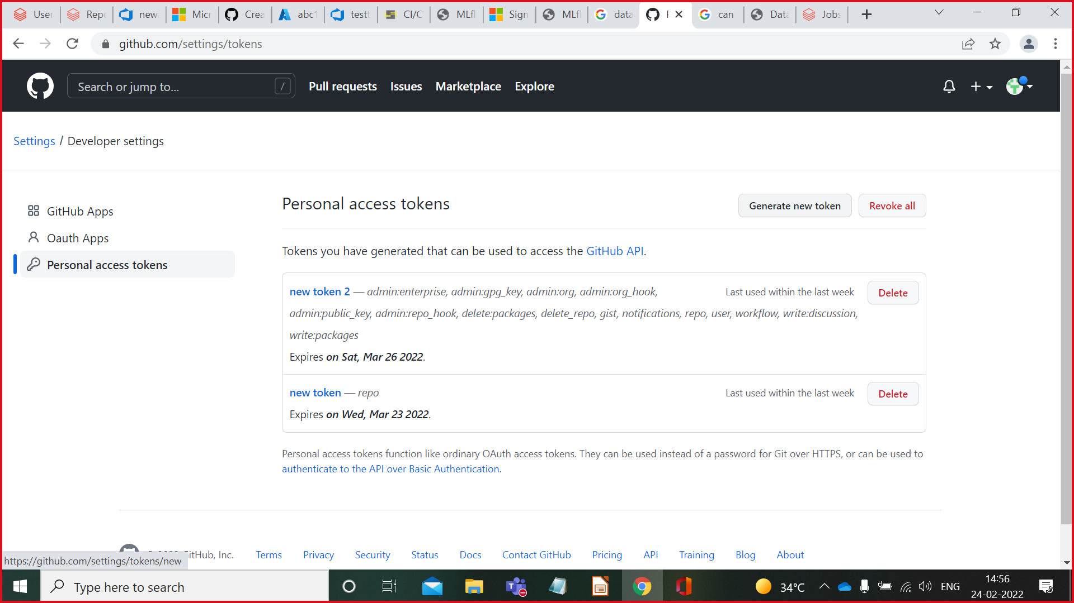

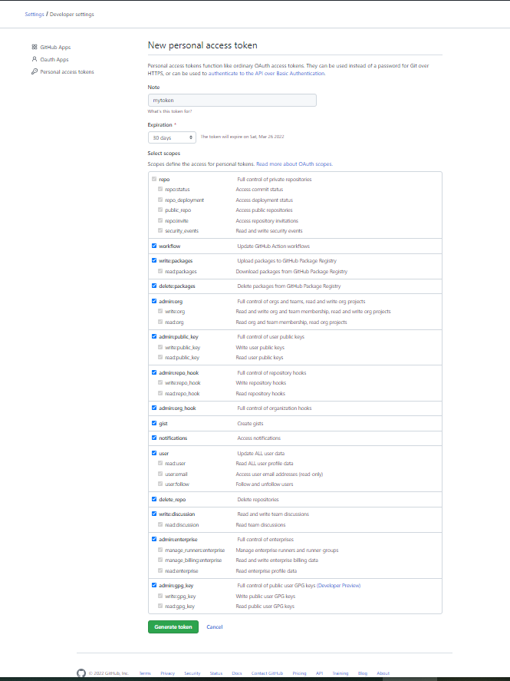

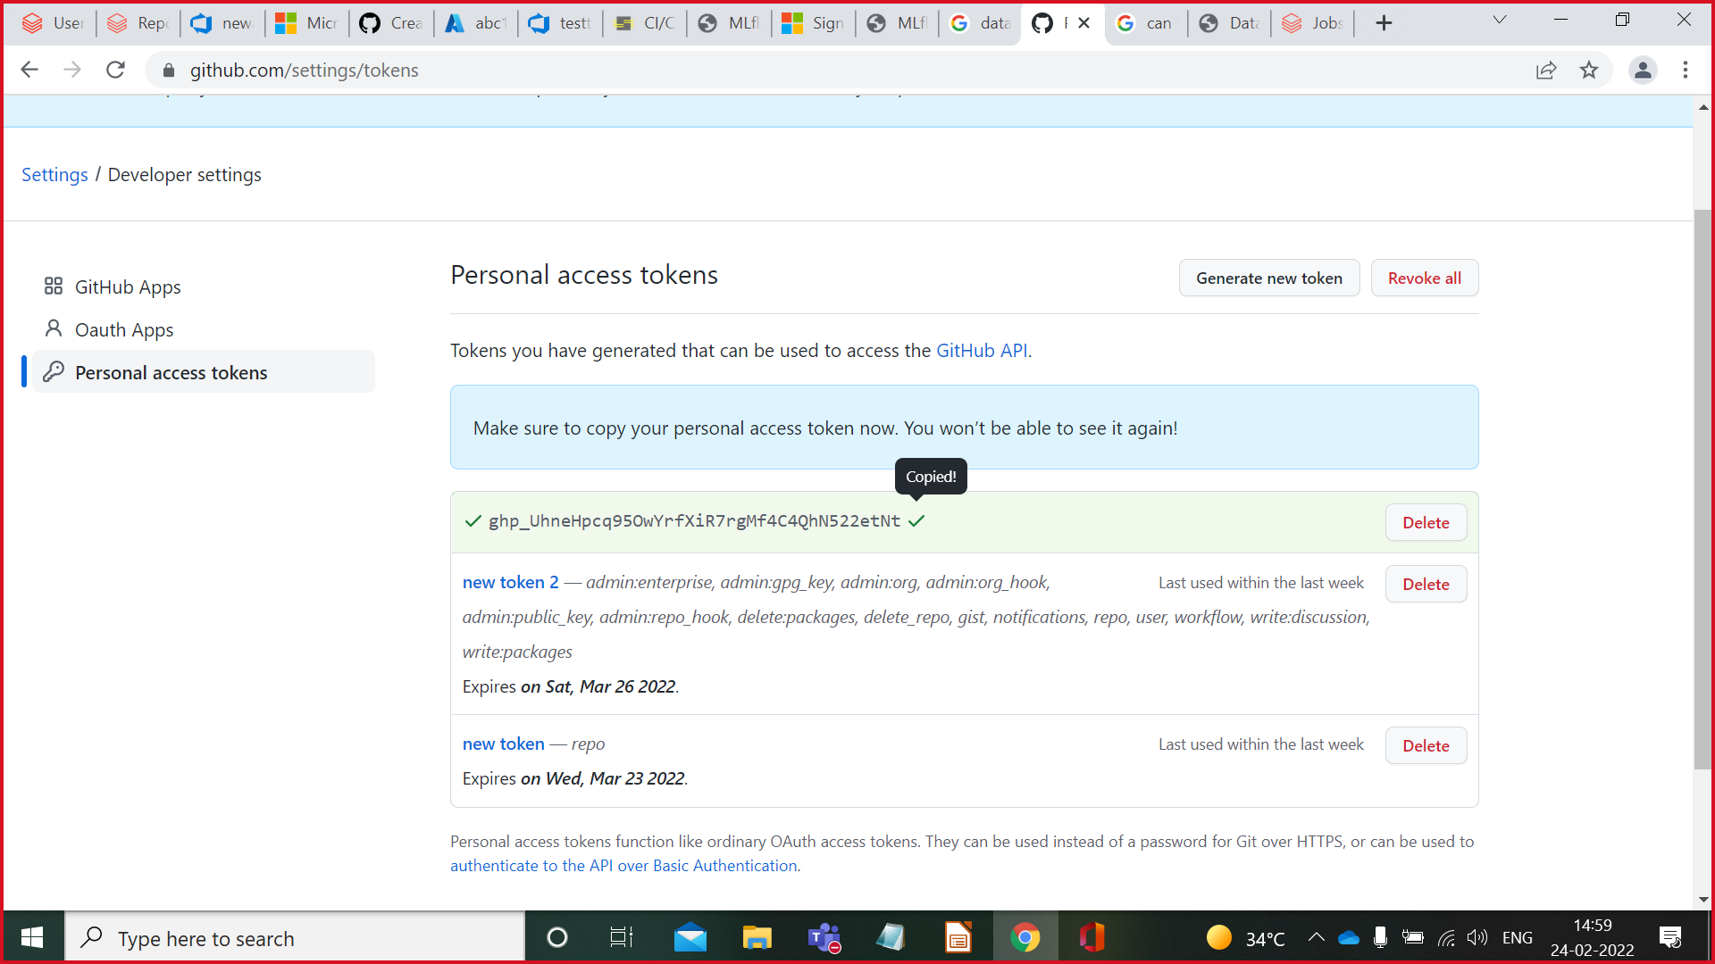

Note:We can regenerate token in Git.

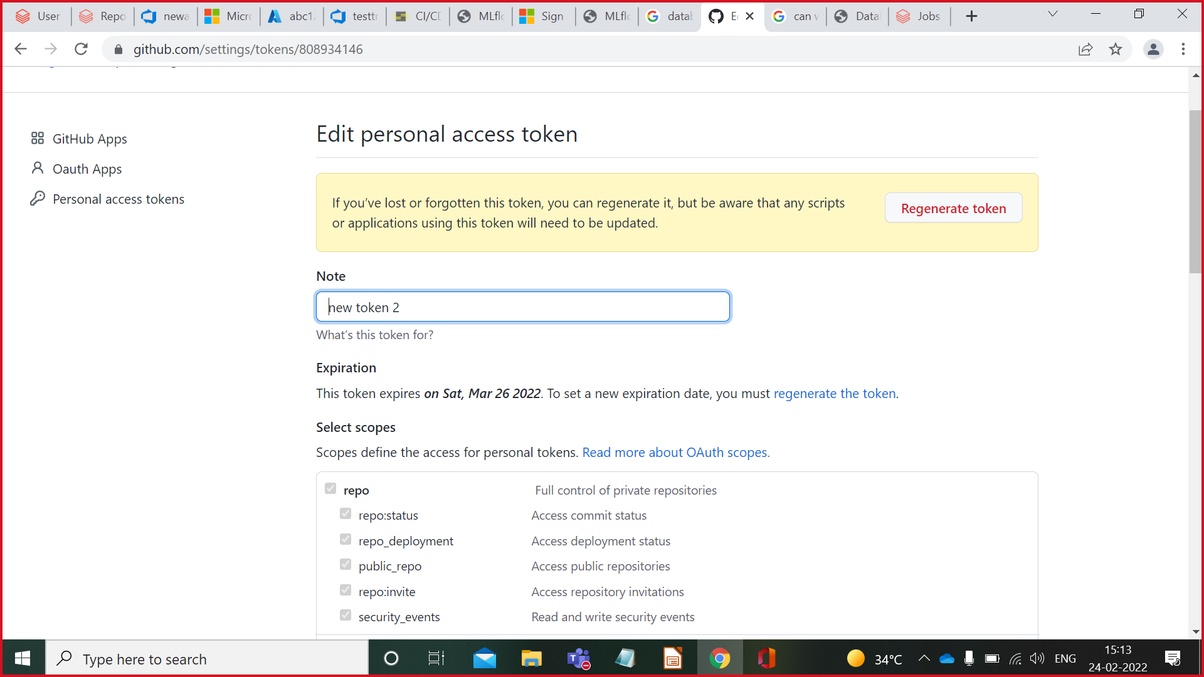

**Linking Databricks Notebook to GIT**

Open notebook--> On top right corner click on Rivision history-->Click **GIT:Not linked**-->

Give git prefernces**((**status-->link**)(**link-->github repo link**)(**branch-->select branch**)(**path-->default**)**-->click on save**).**

You can see **git:synced** in rivision history instead of **git:not linked**.

NOTE:Linking Databricks Notebook to Azure devops is not available in Free Subscription.

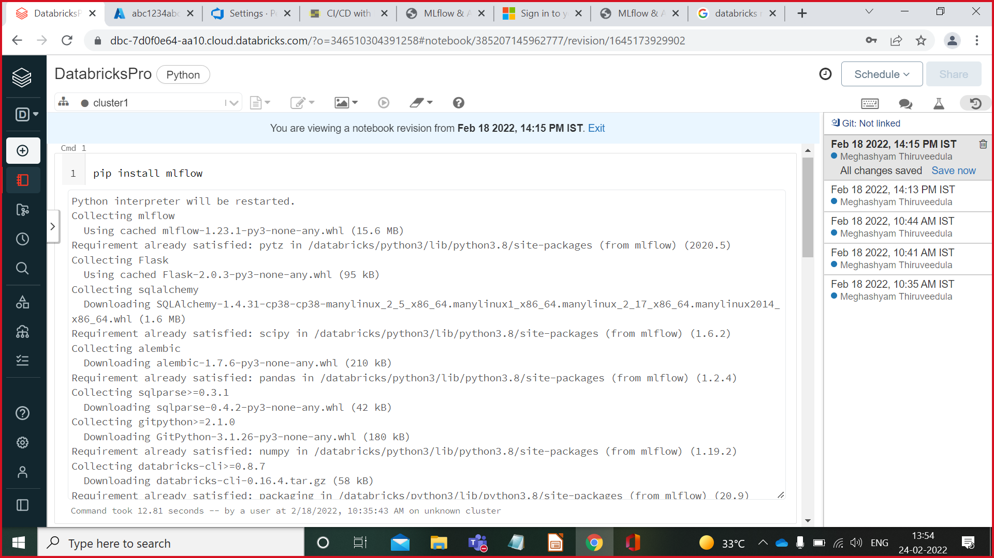

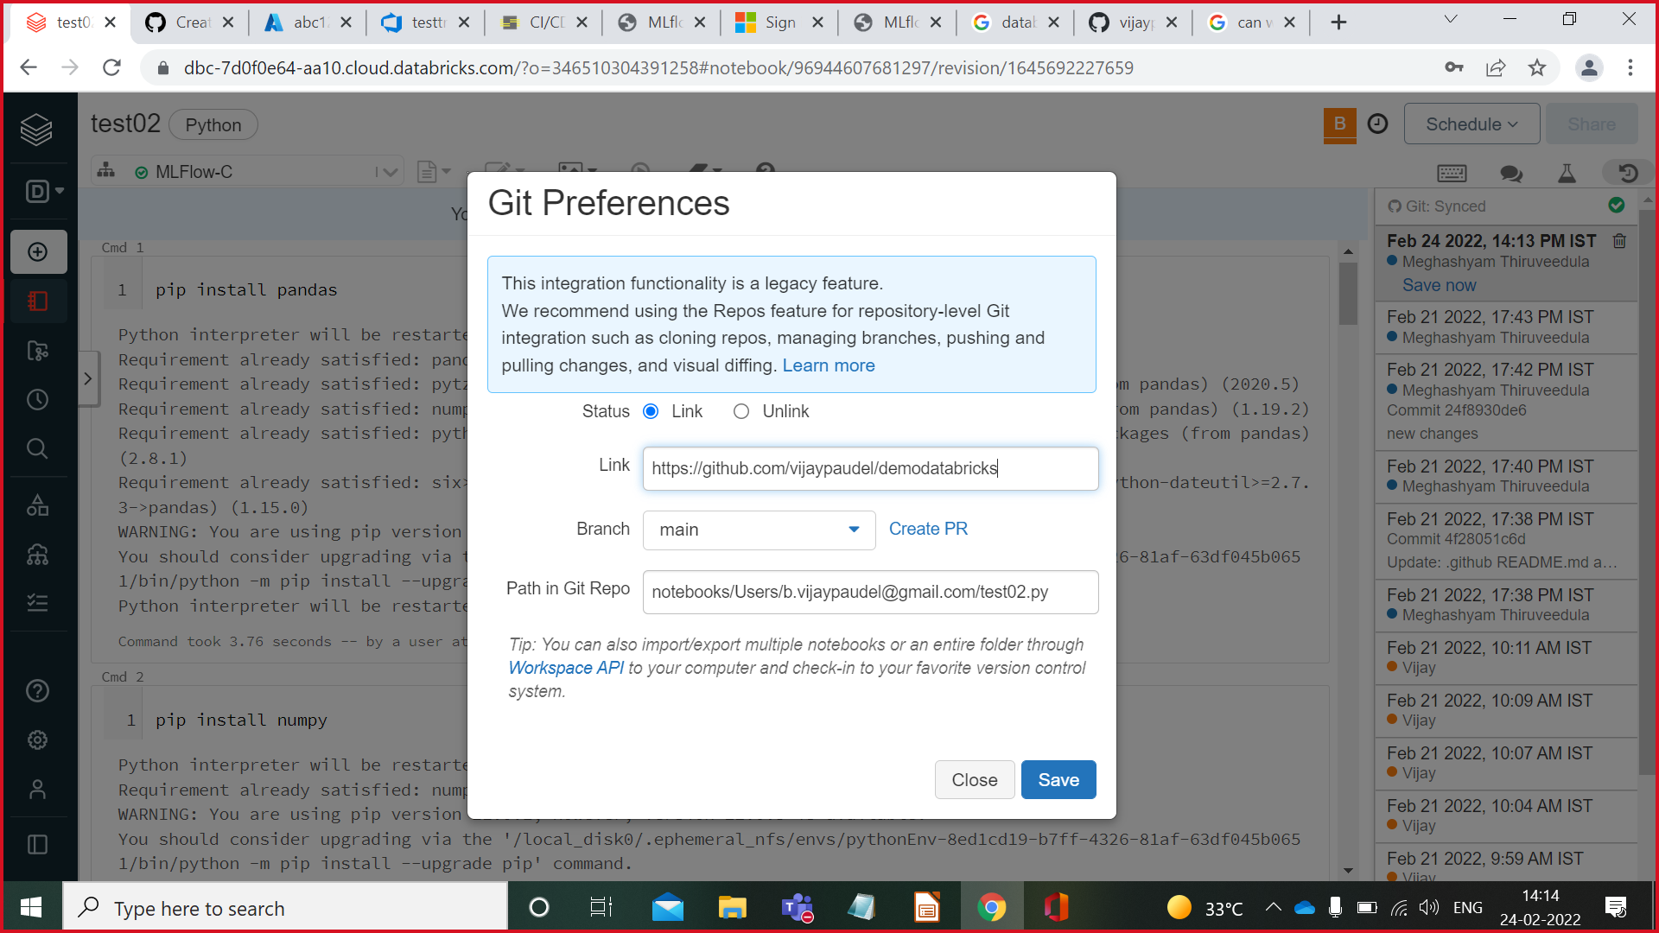

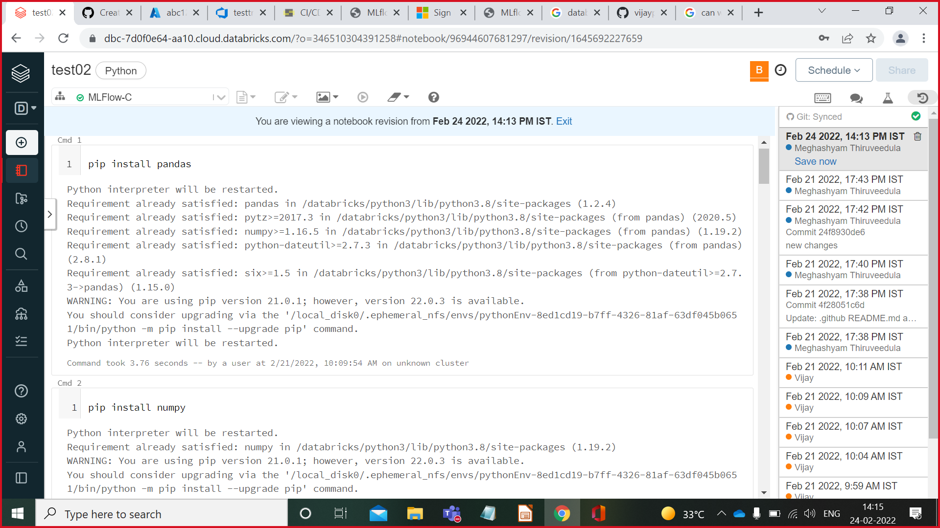

**Update notebook and push it to git**

Open notebook-->Edit code-->On top right corner click on rivision history-->Click on SAVE NOW on right side of notebook-->Give name and also commit in GIT-->Click on Save Button (Changes done in notebook are updated in GIT also).

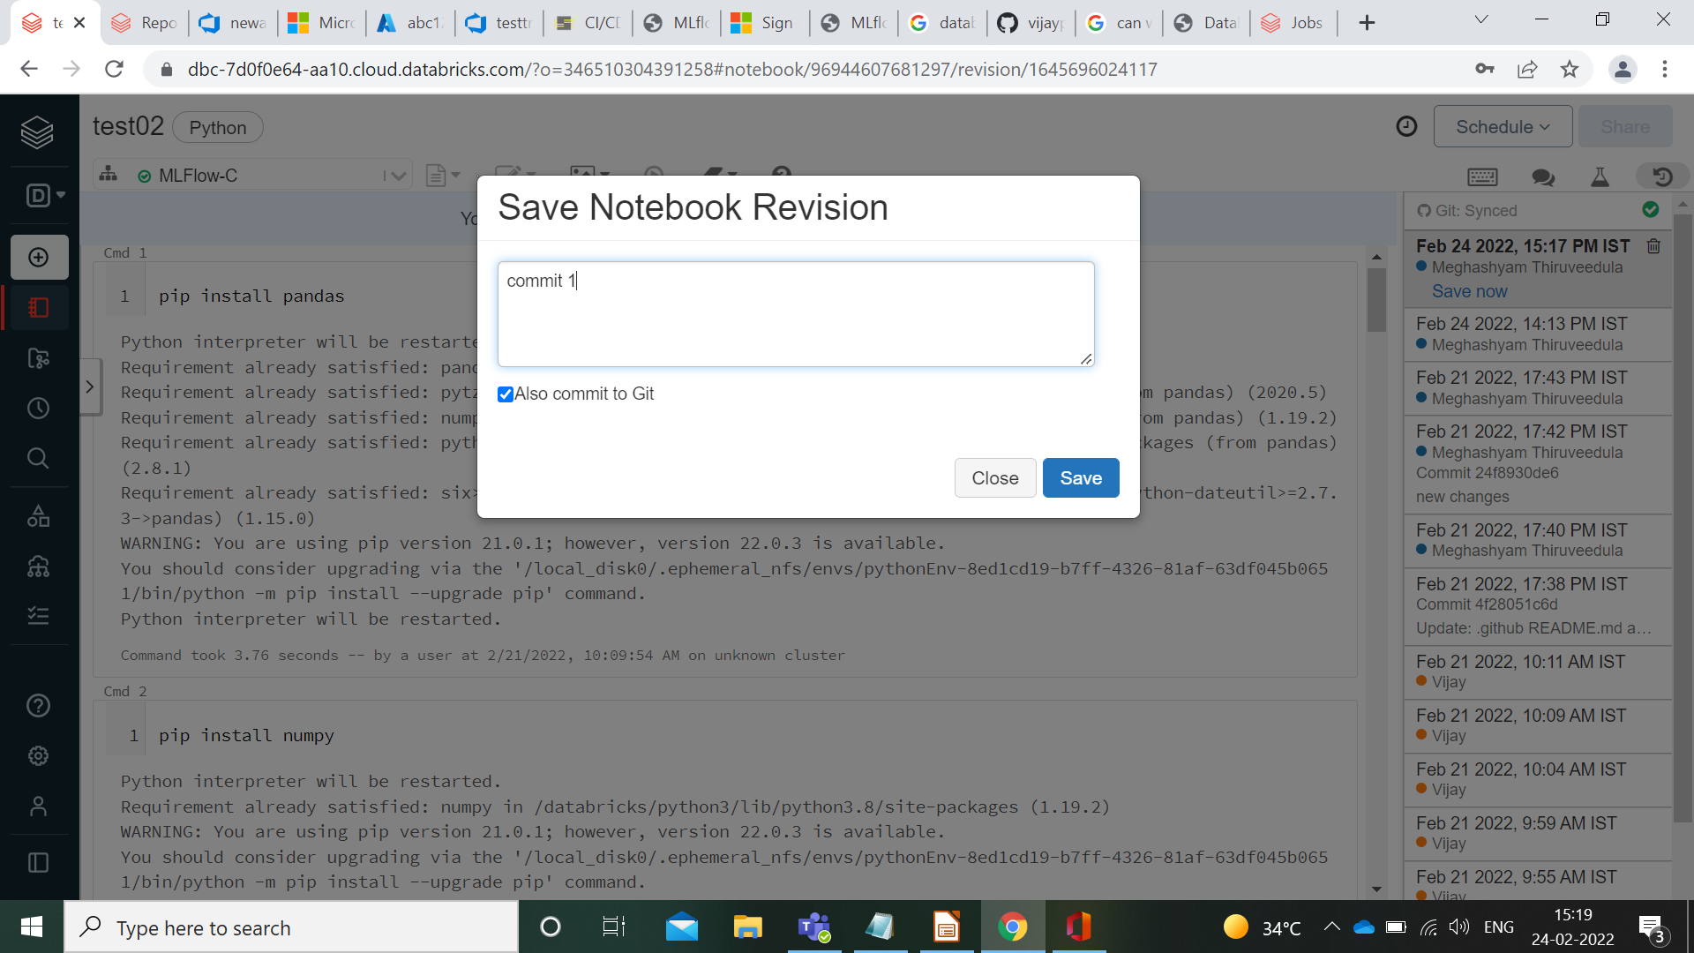

**Add Repo to Azure Devops**

**Prerequisite:Create Project in Azure De**Go to Azure Devops-->Create/Select Project-->Select Repo-->Click on New Repositary-->Give Git Repositary URL in Clone URL-->Click on Import.

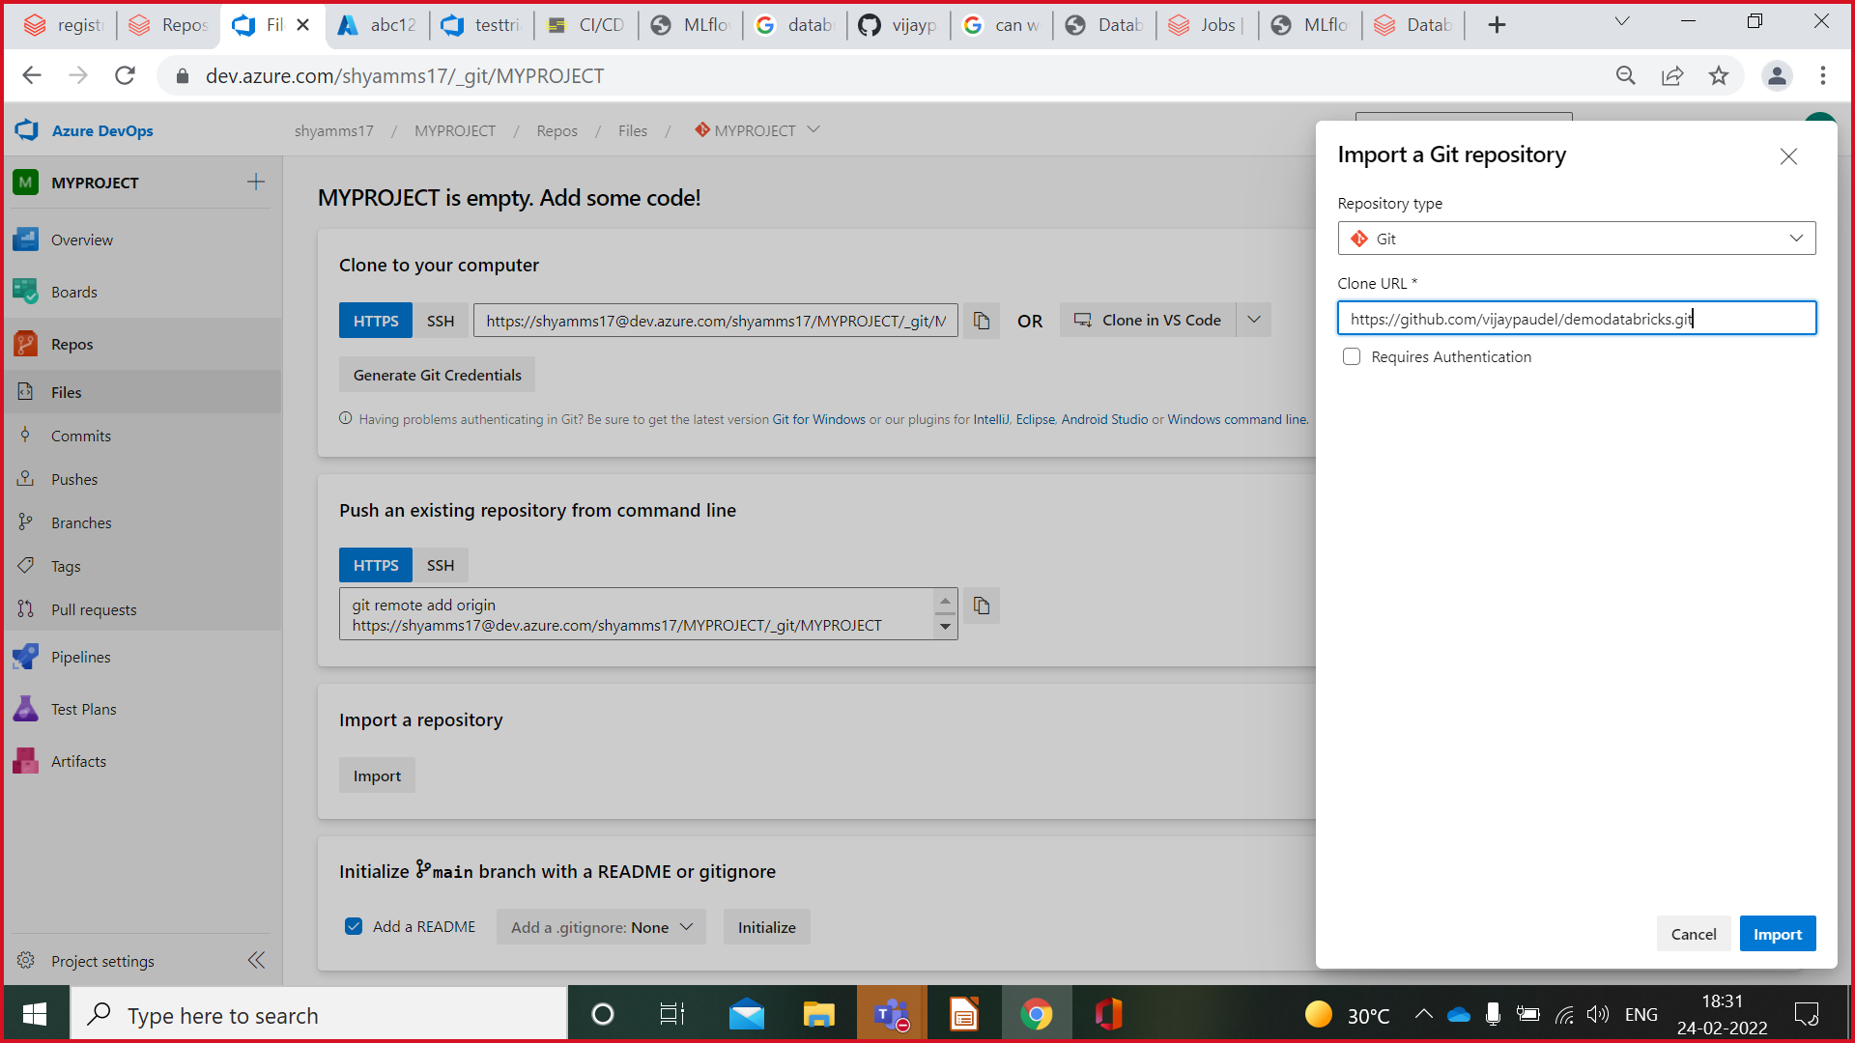

You will get all the files from Git repo to Azure Devops Repo.

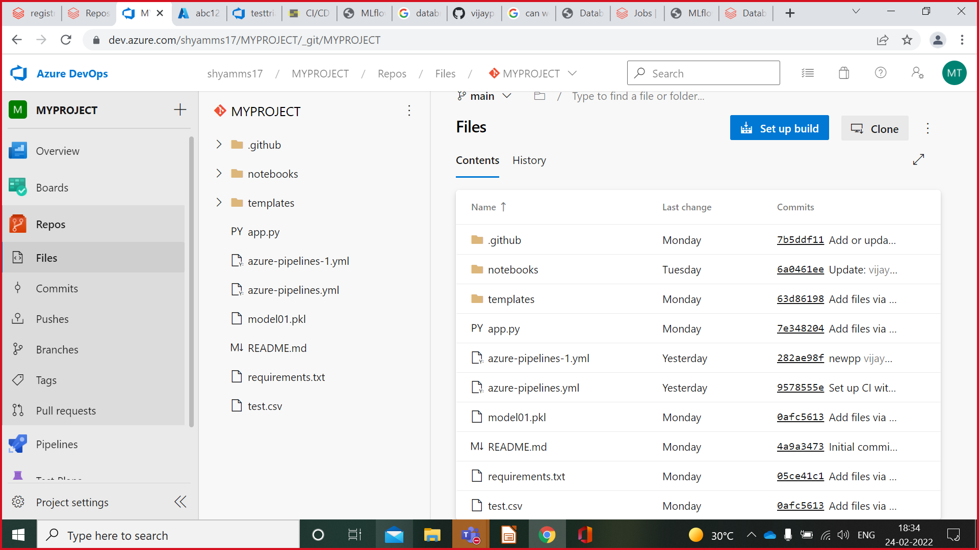

Note:Another option to Add files from local Sytem is by Uploading file in Azure Devops repo

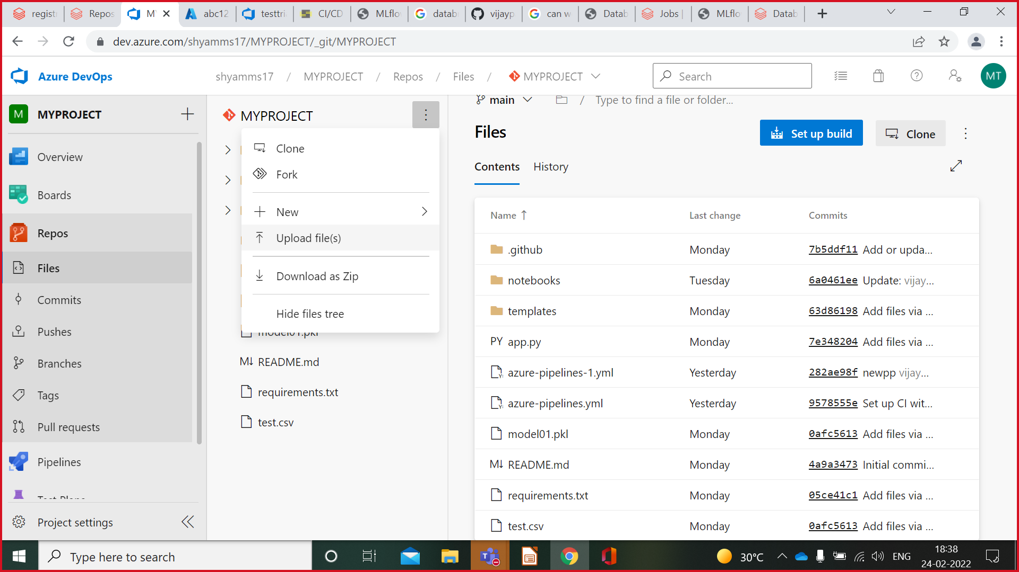

**Adding Repo from Azure Devops To Databricks Repo**

Go to Databricks Repos-->Add repos-->From dropdown select azure devops service-->Add git repo url from devops azure(Click project in azure devops-->Click on repos-->Click on Clone Button-->Copy url)-->Give repo name-->Click on Create Button

**To give permissions:**

Databricks settings-->Admin console-->Workspace integration-->Repos-->Enable all

Files in Azure Devops Repo are added in Databricks repo

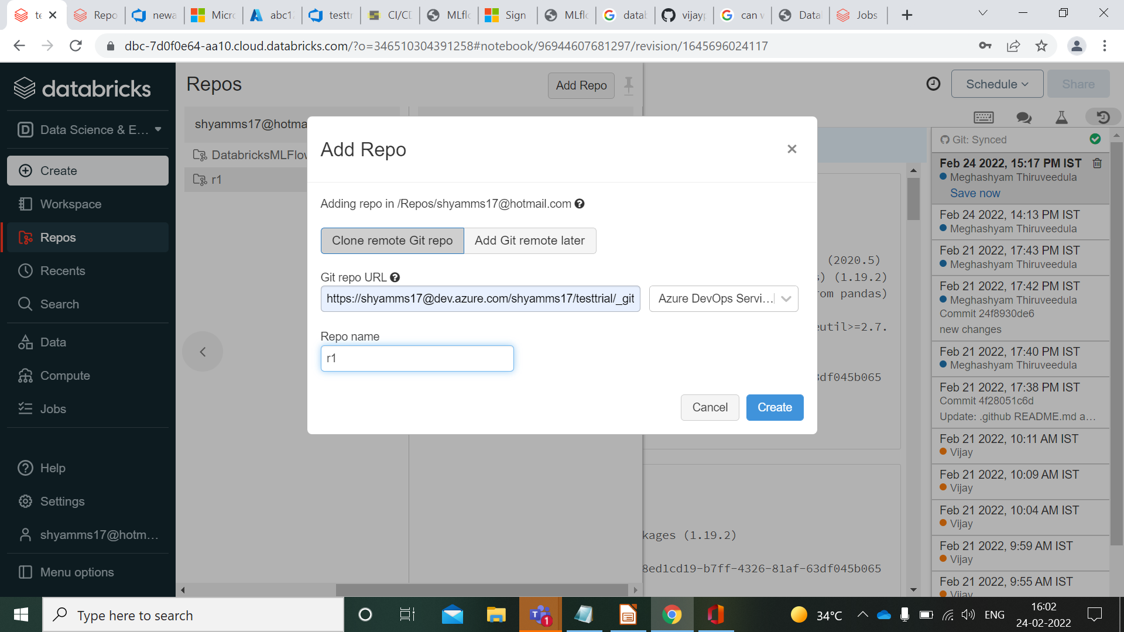

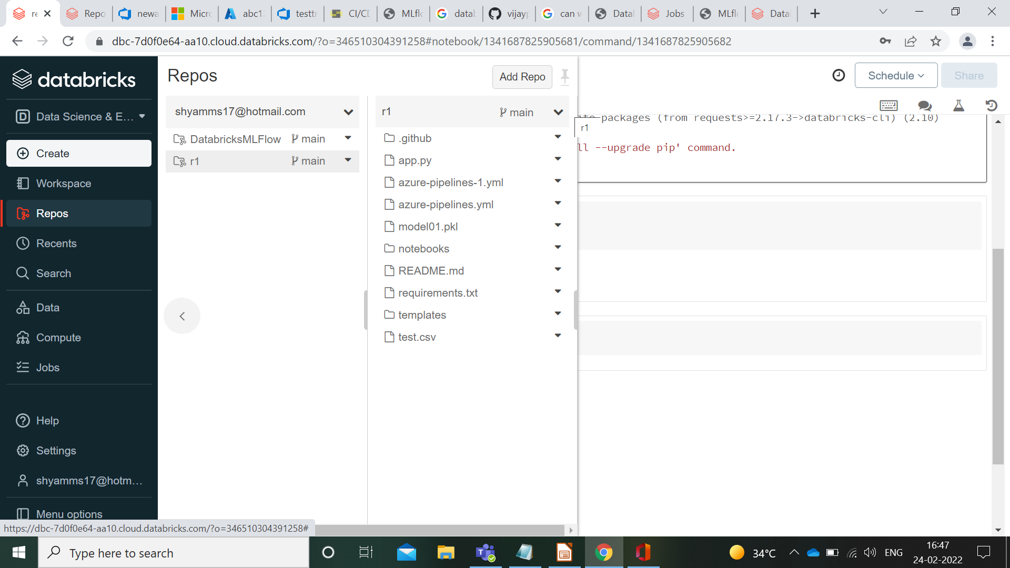

**Deployment in Microsoft Azure through Azure Devops**

Create Microsoft azure account-->Click on CREATE RESOURCE-->Create WEB APP-->Under Basics**(**Add /Create Resource group-->Under Instance Details add Name and Runtime Stack**(**Rest keep default**))**-->Click on Review+Create-->Click on Create-->

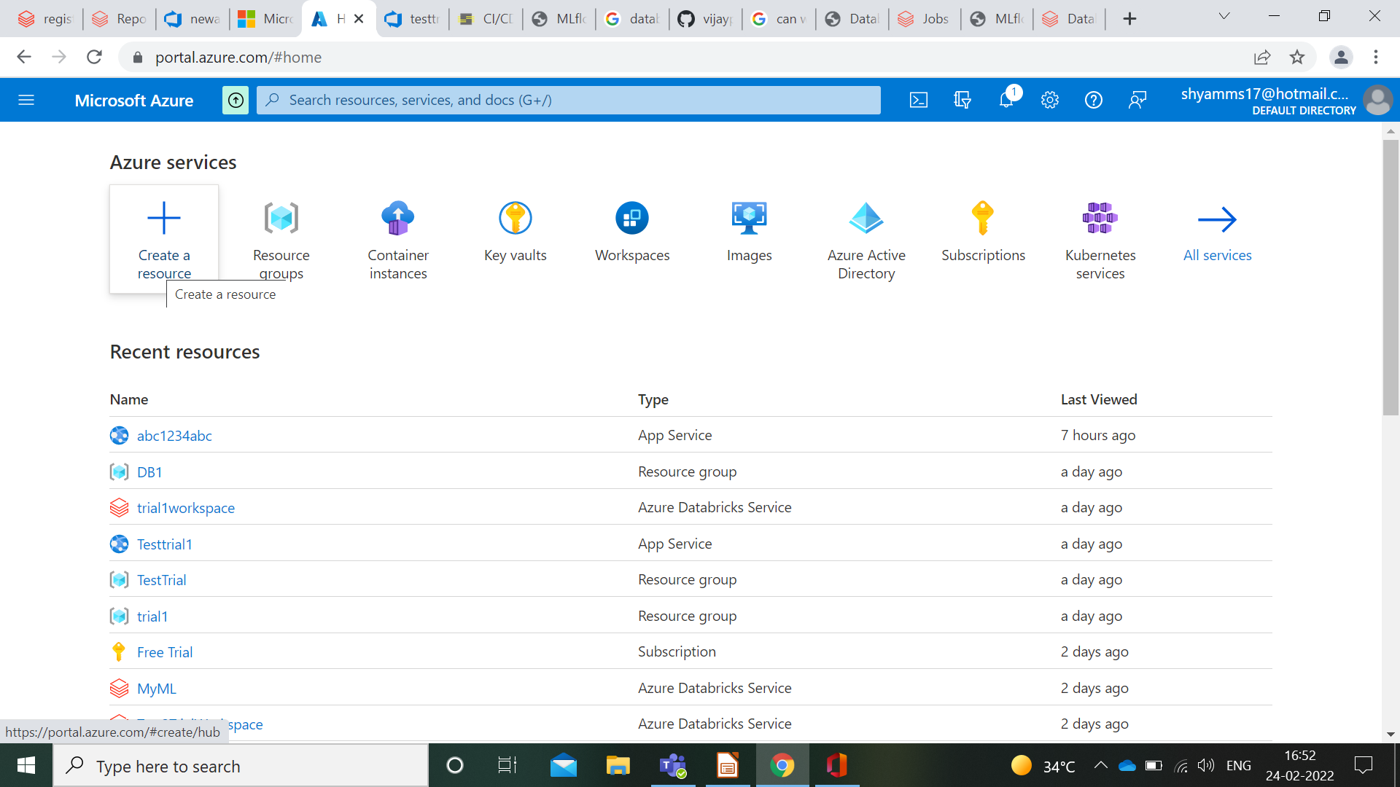

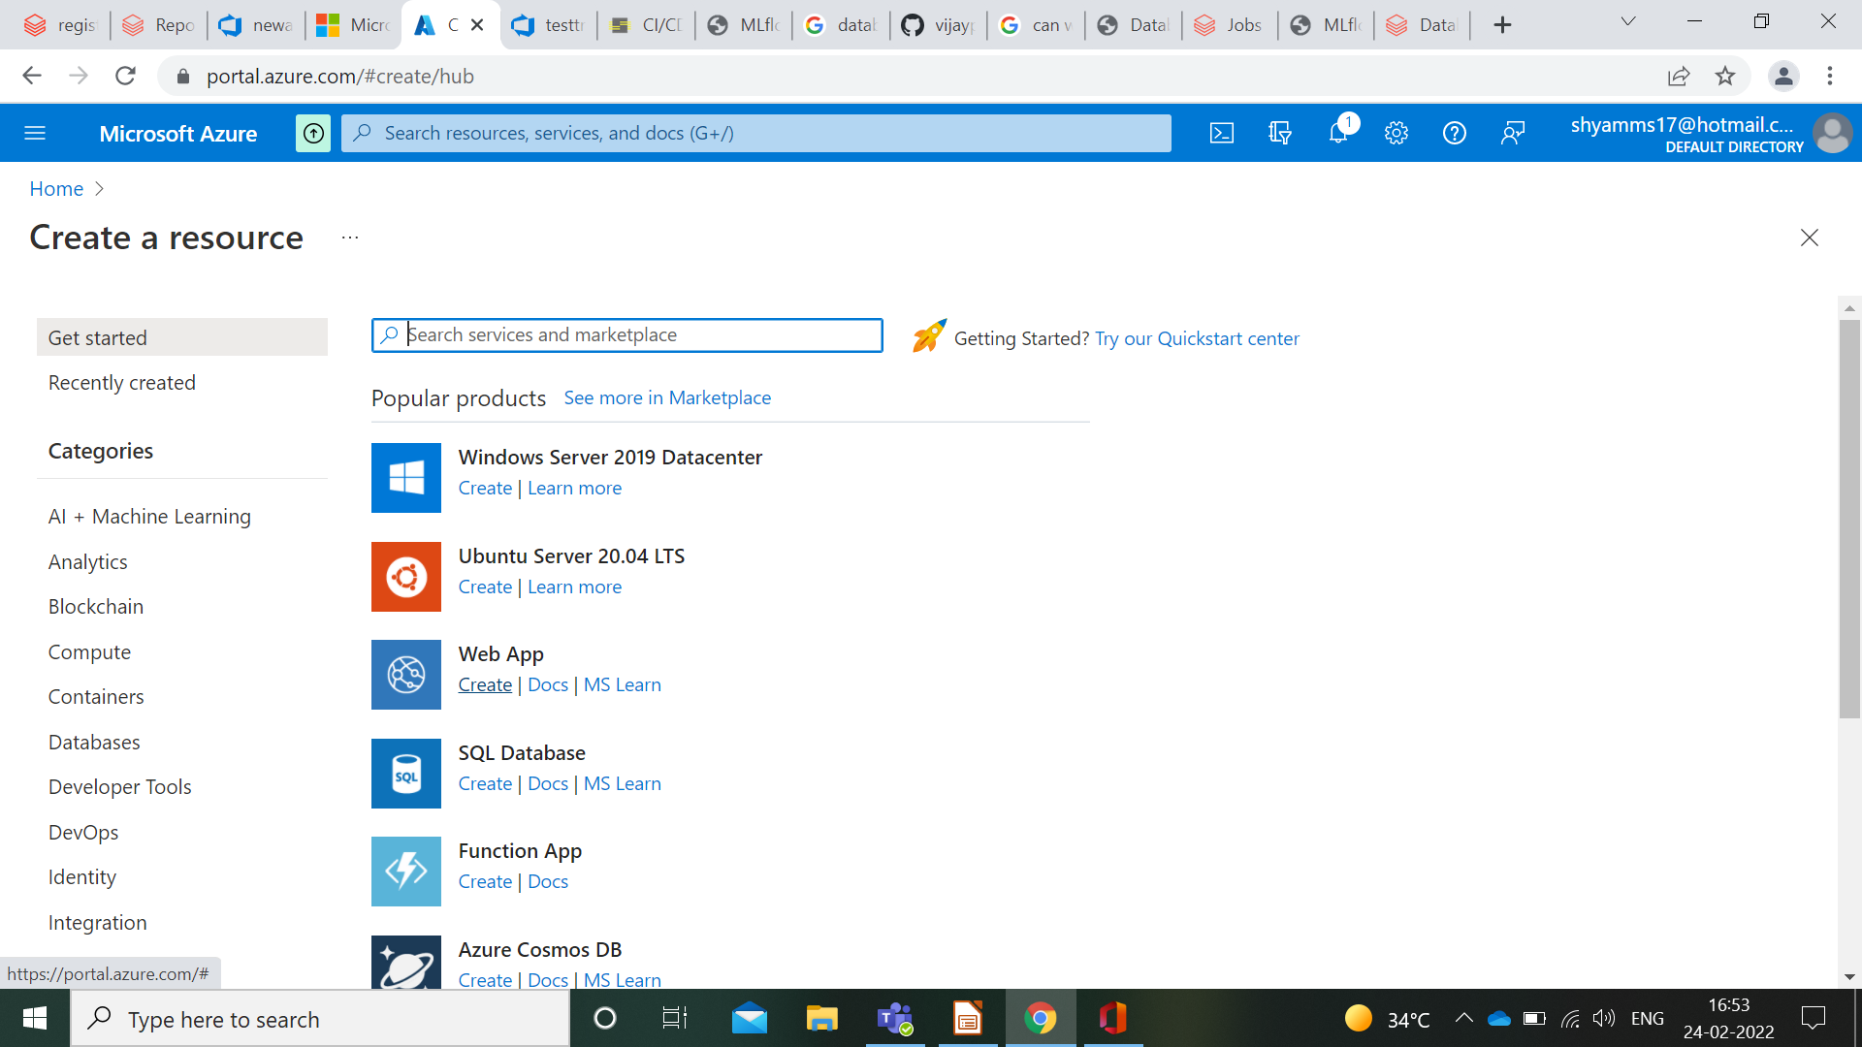

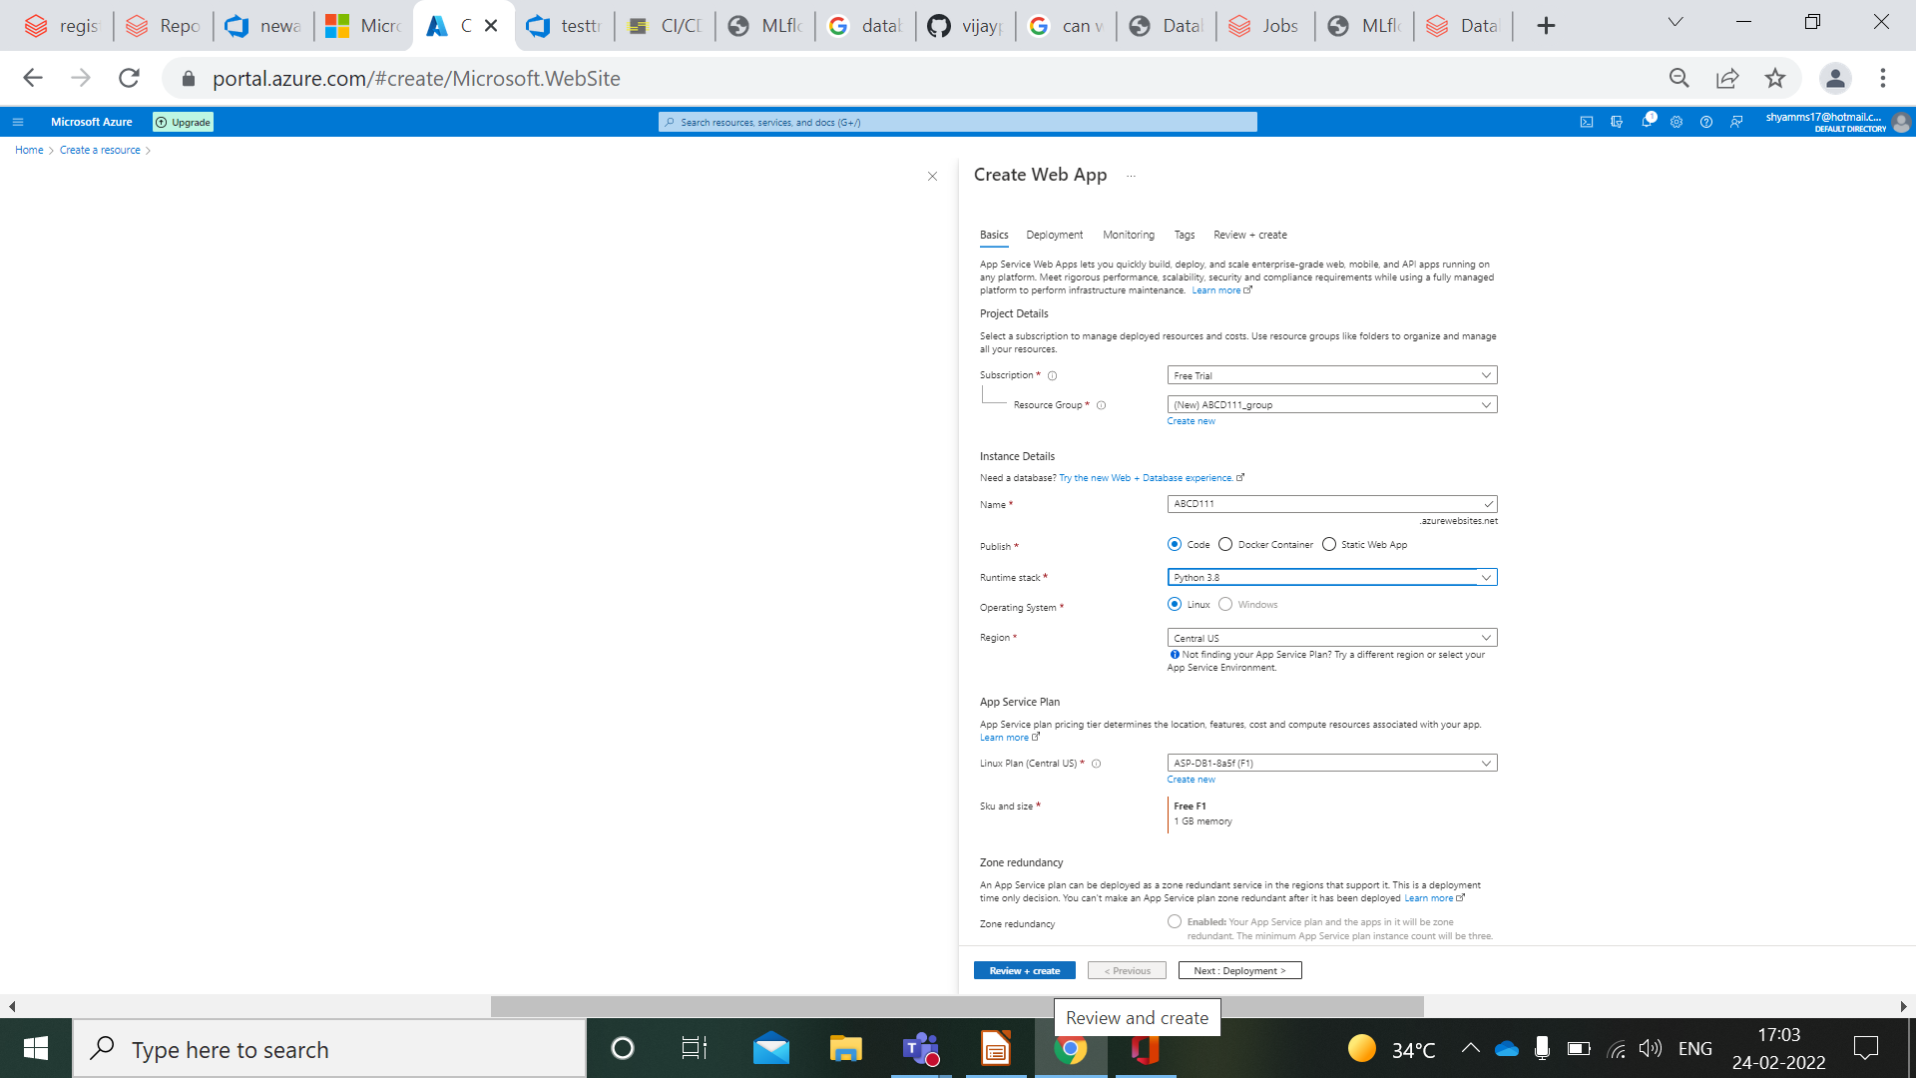

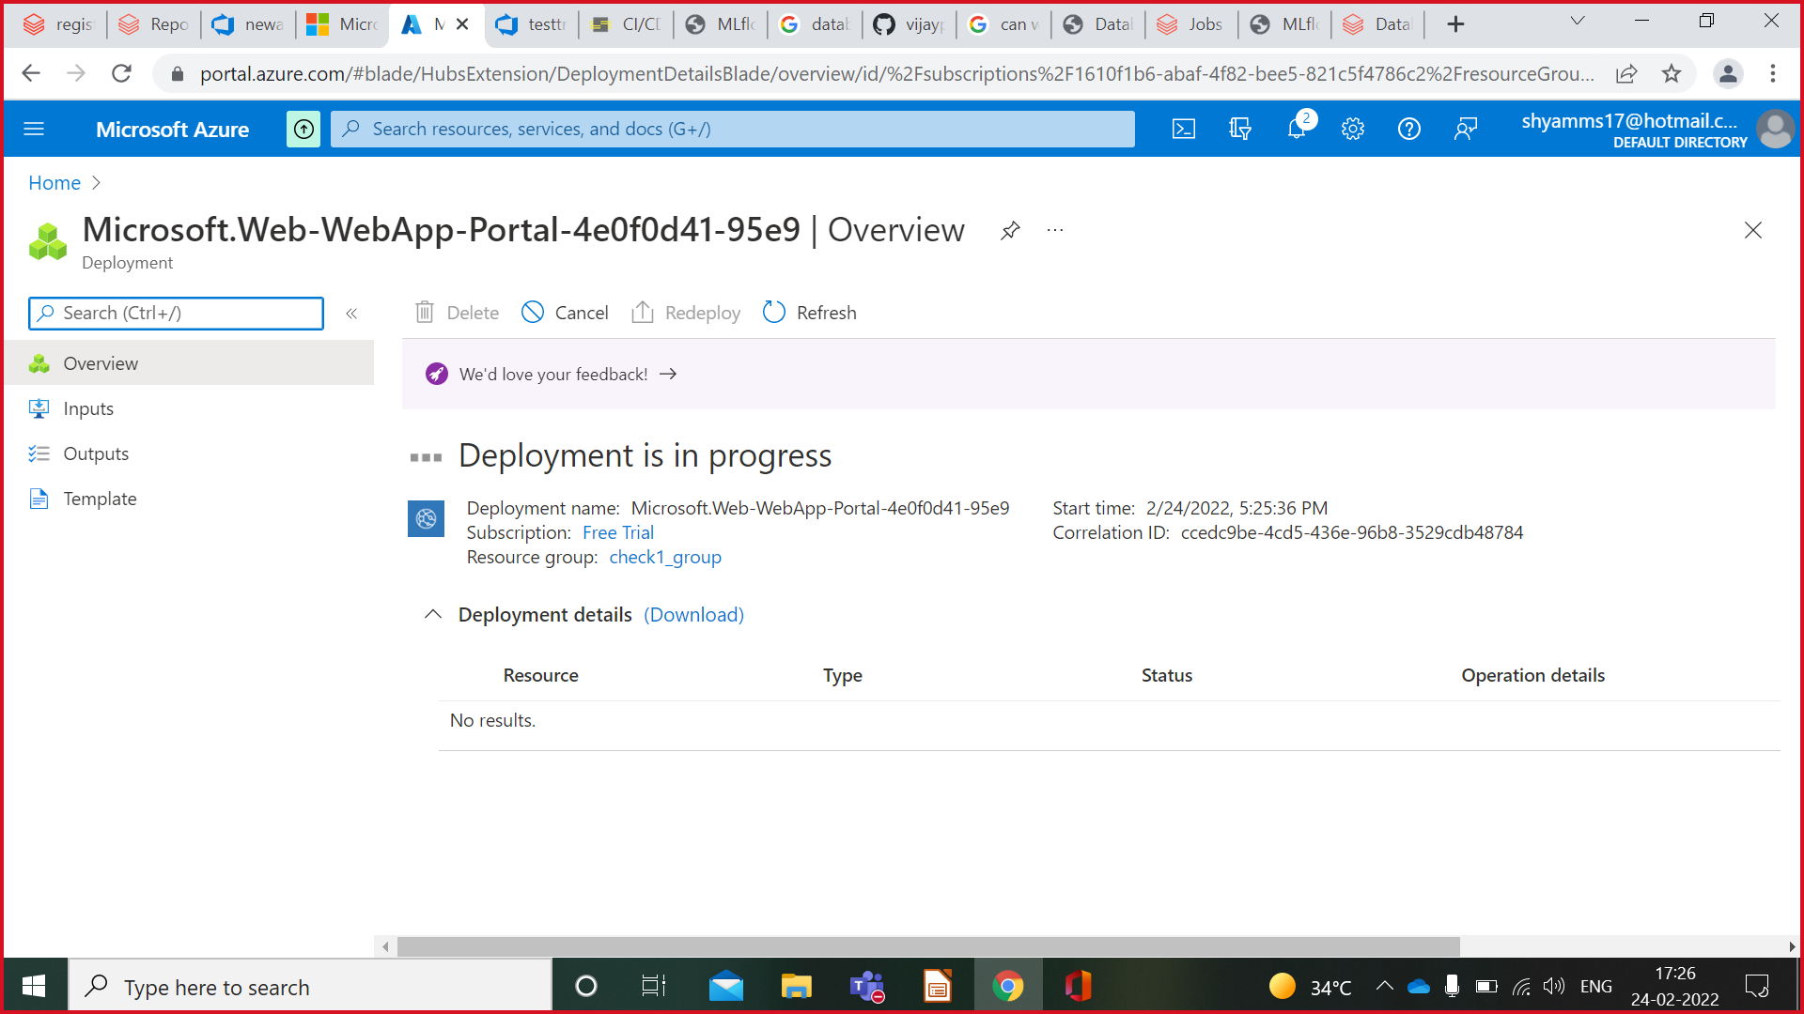

After Succesfull Deployment go to Deployment Center on left-->Under Source select Azure Repos-->Select Appropriate options-->Click on Save

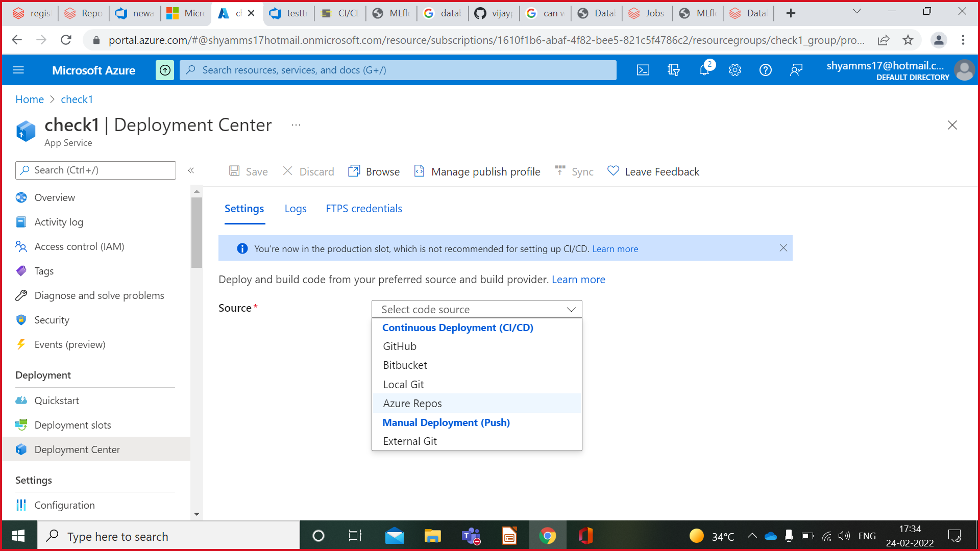

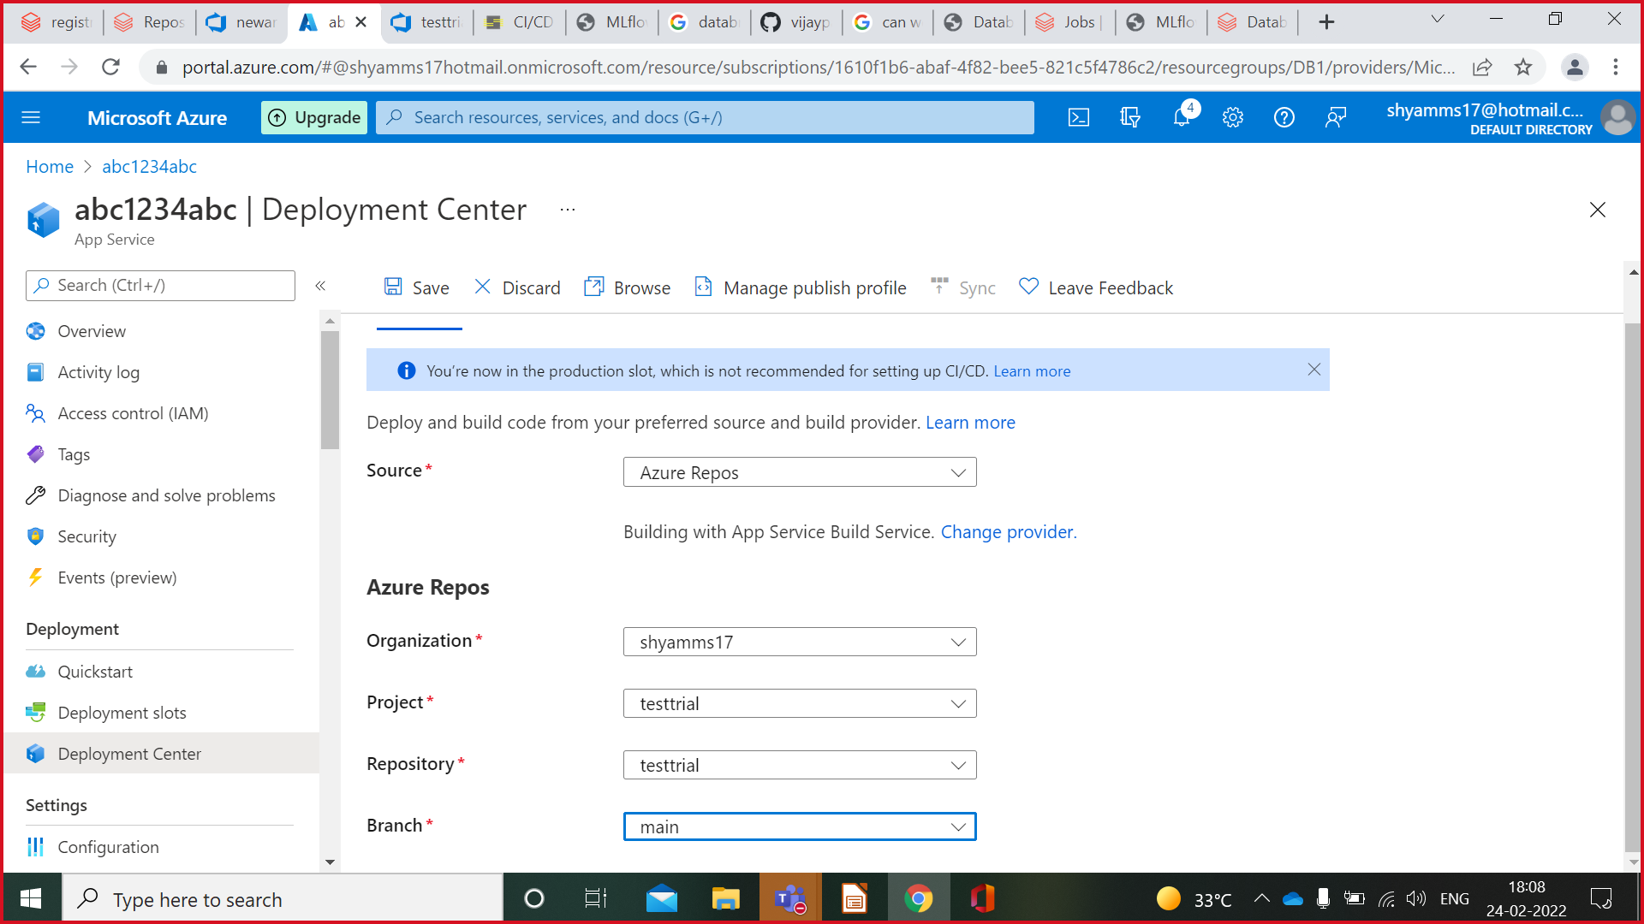

Deployment will start(This will take time)-->Check Logs for Deployment Process-->You will get URL-->Click on that Auto generated URL-->It will Open UI Page of project in new tab.

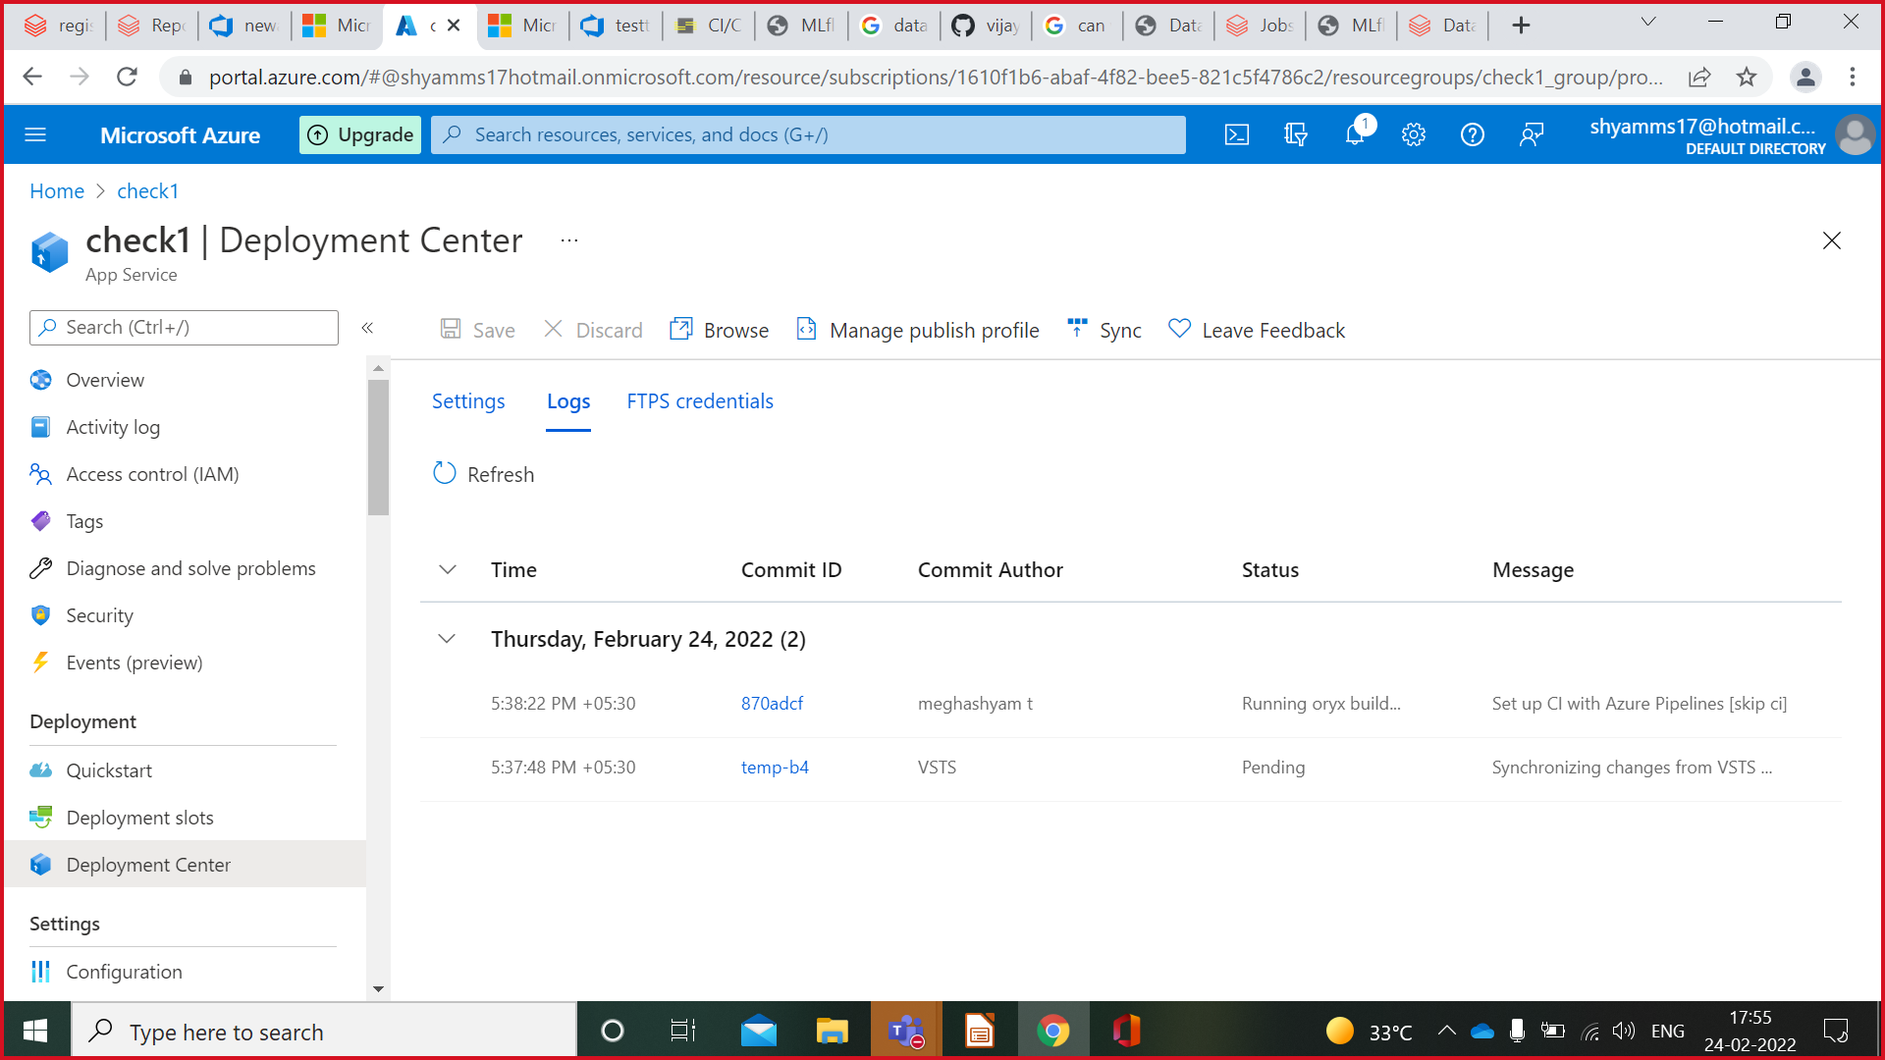

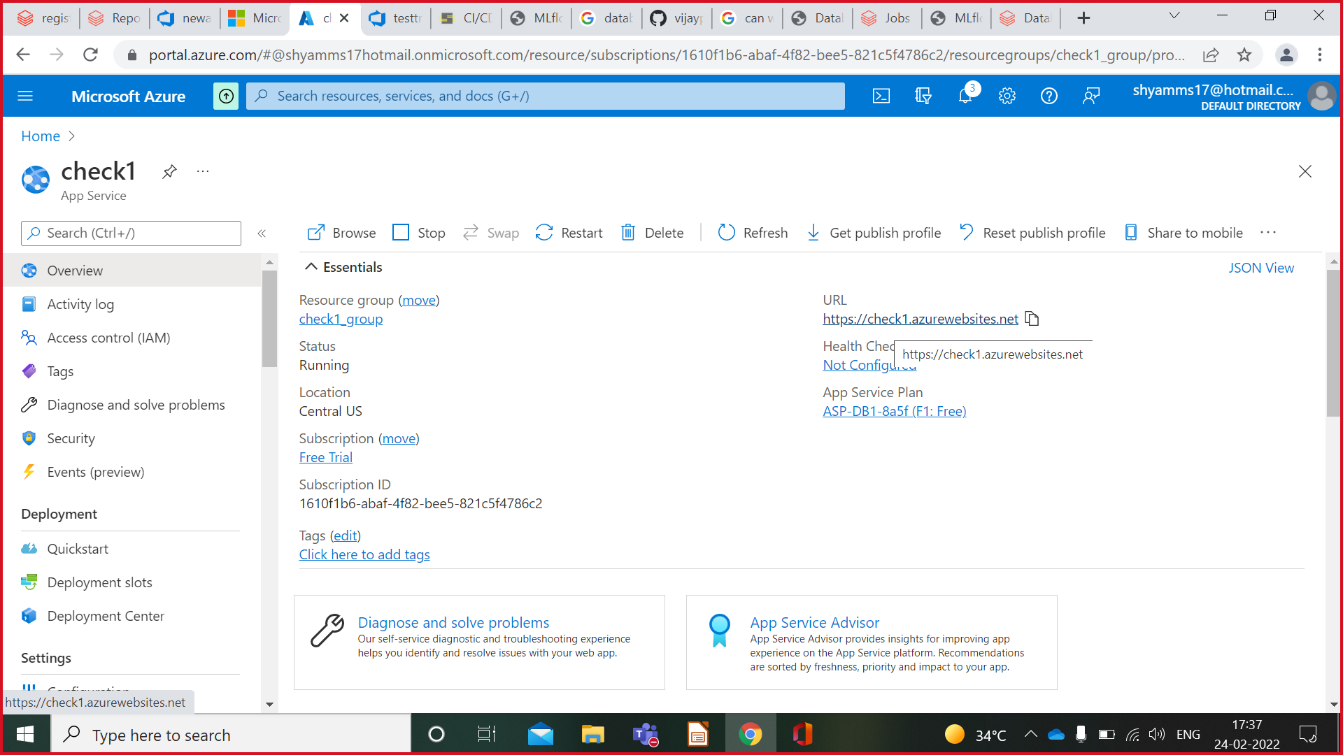

Add Details and Click on Predict Button.



Output shows predicted salary.



**Deployment in Microsoft Azure through Github**

Repeat all steps of **Deployment in Microsoft Azure through Azure Devops** and continue from here:

After Successfull Deployment go to Deployment Center on left-->Under Source Github-->Select Appropriate options-->Click on Save



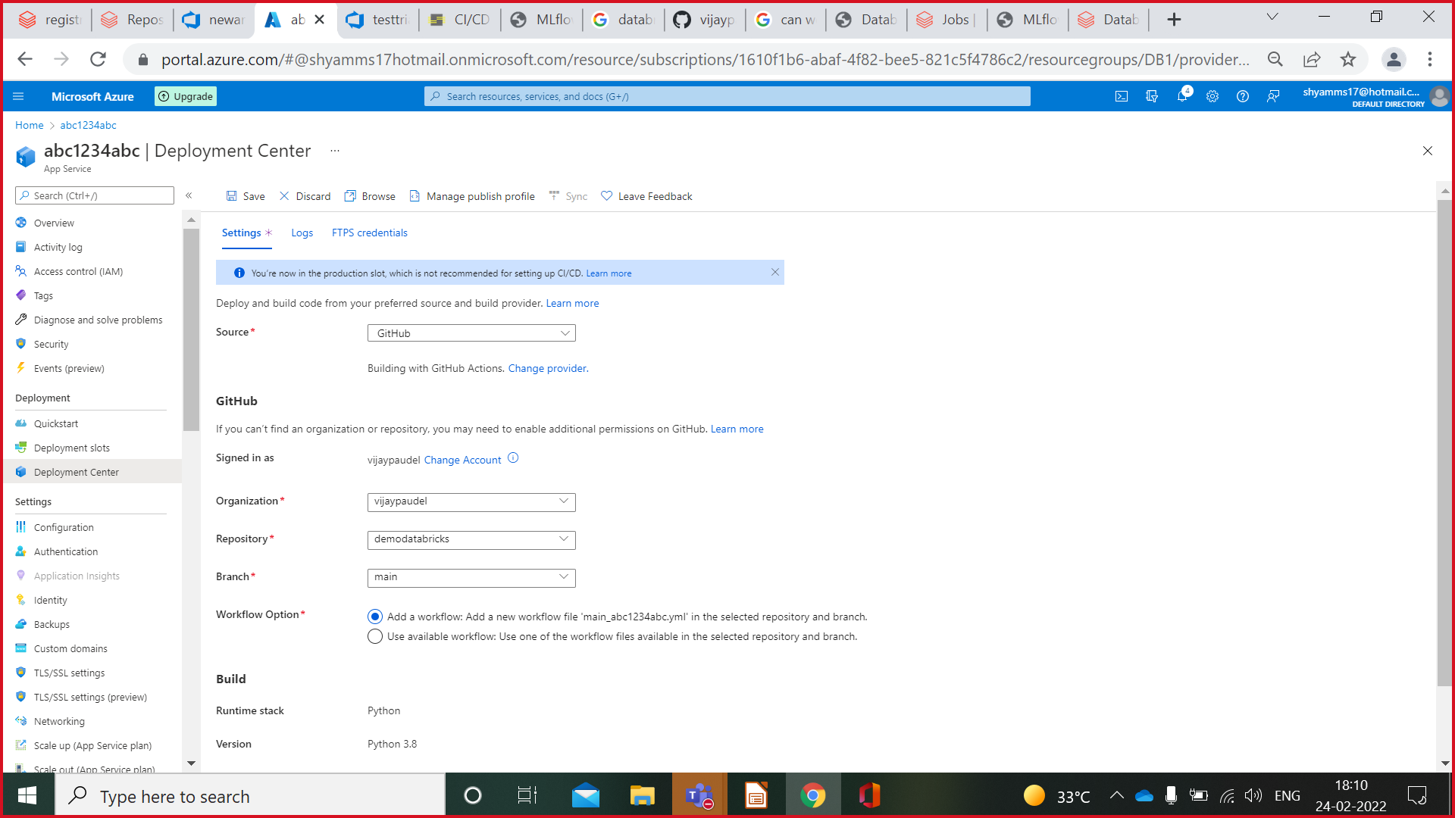

Deployment will start(This will take time)-->Check Logs for Deployment Process-->You will get URL-->Click on that Auto generated URL-->It will Open UI Page of project in new tab.





Add Details and Click on Predict Button.



Output shows predicted salary.



**CI/CD Pipeline**

Continuous integration (CI) and continuous delivery (CD) embody a culture, set of operating principles, and collection of practices that enable application development teams to deliver code changes more frequently and reliably. The implementation is also known as the CI/CD pipeline and is one of the best practices for devops teams to implement.

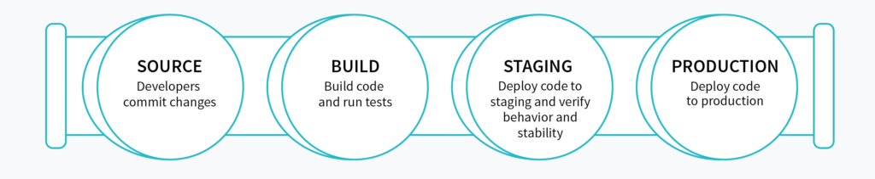

Overview of Azure Databricks CI/CD pipeline

**Continuous integration:**

1) Code

Develop code and unit tests in an Azure Databricks notebook or using an external IDE.

Manually run tests.

Commit code and tests to a git branch.

2) Build

Gather new and updated code and tests.

Run automated tests.

Build libraries and non-notebook Apache Spark code.

3) Release

Generate a release artifact

**Continuous delivery:**

1) Deploy

Deploy notebooks.

Deploy libraries.

2) Test

Run automated tests and report results.

3) Operate

Programmatically schedule data engineering, analytics, and machine learning workflows.

**Example of continuous integration and delivery**

The flow is simple:

* A developer develops
* Then he checks in his code into source control
* The developer branch is then pushed to the master branch
* The code is then pushed to various environment; DEV; TEST; PROD

## **Prerequisites**

Make sure you have the following:

|  |  |  |  |  |  |  |  |  |  |  |  |  |  |  |  |  |
| --- | --- | --- | --- | --- | --- | --- | --- | --- | --- | --- | --- | --- | --- | --- | --- | --- |
| **A Databricks workspace:** You can follow below link if you need to create one.  [**https://docs.microsoft.com/en-us/azure/databricks/scenarios/quickstart-create-databricks-workspace-portal?tabs=azure-portal**](https://docs.microsoft.com/en-us/azure/databricks/scenarios/quickstart-create-databricks-workspace-portal?tabs=azure-portal)  **An Azure DevOps project / Repo:** See see below link on how to create a new Azure DevOps project and repository.  [**https://docs.microsoft.com/en-us/azure/devops/organizations/projects/create-project?view=azure-devops&tabs=preview-page&viewFallbackFrom=vsts**](https://docs.microsoft.com/en-us/azure/devops/organizations/projects/create-project?view=azure-devops&tabs=preview-page&viewFallbackFrom=vsts)  **A Sample notebook we can use for our CI/CD example:** Below link will guide you through creating a sample notebook if you need.  [**https://docs.microsoft.com/en-us/azure/databricks/scenarios/databricks-extract-load-sql-data-warehouse**](https://docs.microsoft.com/en-us/azure/databricks/scenarios/databricks-extract-load-sql-data-warehouse) **Binding your DevOps Project** Next, you will need to configure your Azure Databricks workspace to use Azure DevOps which is explained in this link:[**https://docs.microsoft.com/en-us/azure/databricks/notebooks/azure-devops-services-version-control**](https://docs.microsoft.com/en-us/azure/databricks/notebooks/azure-devops-services-version-control) **Syncing your notebooks a Git Repo** Refer above topic(**Linking Databricks Notebook to GIT**).  **Creating a new build pipeline**    Pressing **"Continue"** will bring you to the template selection screen. The pipeline we're building involves pulling the changes from the master branch and building a drop artifact which will then be used to push to Azure Databricks in the CD part. Knowing this, pick **"Empty job"**.  Name your build pipeline ADBDemo-CI and pick Hosted VS2017 pool.  Next, you will click on the **"+"** sign next to **"Agent job 1"** which will bring up the list of tasks available to you. Search and add **"Publish Build Artifacts"**.  Once added, click on the added task and your screen should now look like this:  AzureDevOps 6 1024x668  A few things of importance to note on this screen; the **Path to publish** and the **Artifact name**.  The task selected will pull artifacts from your Git repository and create a package which will be used by our release pipeline. The **Path to publish** indicates which folder in your git repository you would like to include in your build. Clicking on the ellipsis will let you browse your repository and pick a folder.  The **Artifact name** identifies the name of the package you will use in the release pipeline. You can keep it as **"drop"** for simplicity. **Queuing your build** Once you've defined your build pipeline, it's time to queue it so that it can be built. This is done by selecting the **"Save & queue"** or the **"Queue**" options. Doing so will ask you save and commit your changes to the build pipeline.  AzureDevOps 8  After submitting your build to the queue, you can monitor the progress by clicking the # item on the top left as per the following  Once completed you should see green check marks on all the steps  AzureDevOps 9 1024x604  Completed build. **Viewing the content of the build** You can inspect the content of your build by clicking the **"Artifact"** blue button on the top right. Doing so will allow you the browse the content like so:  AzureDevOps 10 **Building the release pipeline** Now that we have a build created, lets setup the delivery portion of the CI/CD. In order to do this, you will go back to the **"Pipelines"** menu and select **"Release"** and then **"new release pipeline"**.  AzureDevOps 11Like before, you will select an empty template.  Once that is done, you will need to configure 2 sections; **artifacts** and **stages**. In Microsoft documentation, an **artifact** is described as a deployable component of your application. It is typically produced through a Continuous Integration or a build pipeline and a **stage** is described as a *logical* and *independent* entity that represents where you want to deploy a release generated from a release pipeline.  AzureDevOps 12  Again, for simplicity, we'll create 1 stage; let's call it **DEV**. If done right, your screen should look like this:  AzureDevOps 13 1024x333  Setup up a new stage. **Configuring Artifact** Before configuring the stage, we need to specify the artifacts that will be used for this pipeline. This can be done by click **"+ Add"** in the artifact block and specifying the following:  AzureDevOps 14   |  |  | | --- | --- | | Click Add Button. |  | |  |  | |  |  | |  |  |  **Configuring Stage** Next, we'll need to add a task to your DEV stage. This can be done by clicking on the **"1 job, 0 task"** link in the DEV box and then the **"+"** sign next to **Agent job.**  In the search box of the add task screen, search for Databricks and you should see a task available in the marketplace called **Databricks Script Deployment Task by Data Thirst**. This tool will give you the option of deploying scripts, secrets and notebooks to Databricks.  Go ahead and click install.  Once done, you should see new tasks available to you. Select **Databricks Deploy Notebook** and click **Add.**  AzureDevOps 15 1024x476  Now we need to configure the newly added task as per:  AzureDevOps 16 1024x588   |  |  | | --- | --- | | The final step is to create a release:   * click **"+ Release"** drop down. * select **Create a new release**. * Click **Create** on the next screen. |  | |  |  | |  |  | |  |  |  **Creating the release** AzureDevOps 17  AzureDevOps 18  Like before, click the **"Release-#"** link on the top left to see the progress.  If you verify the logs and you release ran successfully, you should see green check marks all across the board. I strongly suggest you go through each steps and look at the outputs as it helps to understand what's going on behind the hood.  AzureDevOps 19  Successful execution. |

**References**

**[https://www.thedataguy.blog/ci-cd-with-databricks-and-azure-devops/#syncing-your-notebooks-a-git-repo](https://www.thedataguy.blog/ci-cd-with-databricks-and-azure-devops/" \l "syncing-your-notebooks-a-git-repo)**

[**https://cprosenjit.medium.com/mlflow-azure-databricks-7e7e666b7327**](https://cprosenjit.medium.com/mlflow-azure-databricks-7e7e666b7327)

[**https://docs.databricks.com/getting-started/quick-start.html**](https://docs.databricks.com/getting-started/quick-start.html)

[**https://docs.databricks.com/applications/mlflow/end-to-end-example.html**](https://docs.databricks.com/applications/mlflow/end-to-end-example.html)